**A PROJECT REPORT**

**on**

**Telos touch**

**Submitted in partial fulfillment of the**

**Requirements for the Degree of**

**MASTER OF COMPUTER APPLICATIONS**

**Submitted By**

**Aniket Kumar**

**University Roll. No.**

**1900290149016**

**Submitted to**

**Dr. Sangeeta Arora**

**(Associated Professor)**

**Computer Applications**



**Department of Computer Applications,**

**KIET Group of Institutions,**

**Delhi-NCR, Ghaziabad**

**(July 2021)**

**DECLARATION**

I hereby declare that the work presented in this report entitled “Telos touch”, was carried out by me. I have not submitted the matter embodied in this report for the award of any other degree or diploma of any other University or Institute.

I have given due credit to the original authors/sources for all the words, ideas, diagrams, graphics, computer programs, experiments, results, that are not my original contribution. I have used quotation marks to identify verbatim sentences and given credit to the original authors/sources.

I affirm that no portion of my work is plagiarized, and the experiments and results reported in the report are not manipulated. In the event of a complaint of plagiarism and the manipulation of the experiments and results, I shall be fully responsible and answerable.

Name : Aniket Kumar

Roll. No. : 1900290149016

Branch : Master of Computer Applications

**(Candidate Signature)**

**CERTIFICATE**

Certified that **Aniket Kumar** (**1900290149016**) has carried out the project work presented in this report entitled “**Telos touch**” for the award of **Master of Computer Application** from Dr. A.P.J. Abdul Kalam Technical University, Lucknow under my supervision. The report embodies result of original work, and studies are carried out by the student himself and the contents of the report do not form the basis for the award of any other degree to the candidate or to anybody else from this or any other University.

**Dr. Sangeeta Arora External Examiner**

Associate Professor

Dept. of Computer Applications

KIET Group of Institutions, Ghaziabad

**Dr. Ajay Kumar Srivastava**

Professor & Head

Department of Computer Application

KIET Group of Institutions, Ghaziabad

Date:

**ACKNOWLEDGEMENT**

Success in life is never attained single handedly. My deepest gratitude goes to my thesis supervisor, **Dr. Sangeeta Arora** for her guidance, help and encouragement throughout my research work. Their enlightening ideas, comments, and suggestions.

Words are not enough to express my gratitude to Dr. Ajay Kumar Shrivastava, Professor and Head, Department of Computer Applications, for his insightful comments and administrative help at various occasions.

Fortunately, I have many understanding friends, who have helped me a lot on many critical conditions.

Finally, my sincere thanks go to my family members and all those who have directly and indirectly provided me moral support and other kind of help. Without their support, completion of this work would not have been possible in time. They keep my life filled with enjoyment and happiness.

**Aniket kumar**

**1900290149016**

**Table of Contents**

|  |  |
| --- | --- |
| Declaration | ii |
| Certificate | iii |
| Acknowledgements | iv |
| Table of Contents | v |
| List of figures | viii-ix |
| List of Tables | x |

**Chapter 1: Introduction** 1

1.1 INTRODUCTION 1

1.2 Benefits of Testing 1

1.3 Modify Code with Confidence 1

1.4 Identify Bugs Early 1

1.5 Improve System Design 1-2

**Chapter 2: LITERATURE REVIEW**

2.1 Testing 3-4

#### 2.2 Introduction 4-5

**Chapter 3: HISTORY OF TESTING** 6

**Chapter 4: TESTING CONCEPT**

4.1 Testing Methodologic: 7

4.2 Level of testing 7

4.3 Type of testing 7

4.4 STLC 7

4.5 Testing 8

4.6 Test planning 8

4.7 Test cases 11

4.8 Positive Test Cases 12

4.8 Negative test case 13

**Chapter 5: CODING** 14-66

**Chapter 6: SYSTEM TESTING** 67

6.1Software Validation 67

6.2 Software Verification 67

6.3 Manual Vs Automated Testing 68

6.4 Testing Approaches 68-69

6.5 Black box testing 69

6.6 White-box testing 70

6.7 Testing Levels 70

6.8 Unit Testing 70

6.9 Integration Testing 71

6.10 System Testing 71

6.11Regression Testing 72

## 6.12 Testing vs. Quality Control, Quality Assurance and Audit 73

**Chapter 7: SALESFORCE** 74

7.1 Salesforce ORG: 75

7.2 Why Salesforce? 75

7.3 Salesforce Lighting ORG 76

7.4 Salesforce Classic ORG 76

7.5 Sandbox ORG 77-79

7.6 Apex jobs 80

7.7 Apex classes 81

7.8 Apex Trigger 81

**Chapter 8:**

8.1 Output screen 82-83

**Chapter 9:**

9.1 Introduction to Assigned Job 84-86

**Chapter 10: INSTALLATION GUIDE** 87-96

10.1Installation and configuration Guide (Telos Touch App) 87-96

**Chapter 11: CONCLUSION** 97

**Chapter 12: REFERENCE** 98-99

**List of figures**

|  |  |  |
| --- | --- | --- |
| fig 6.1 1 | Black-box testing | 69 |
| fig 6.1 2 | White box testing | 70 |
| fig 7.1 1 | Salesforce Profile | 75 |
| fig 7.1 2 | Salesforce Lightning org | 76 |
| fig 7.1 3 | Salesforce Classic org | 76 |
| fig 7.1 4 | Sandbox org Home | 77 |
| fig 7.1 5 | Sandbox org Leads | 77 |
| fig 7.1 6 | Sandbox org Contacts | 78 |
| fig 7.1 7 | Sandbox org Campaigns | 78 |
| fig 7.1 8 | Sandbox org Task | 79 |
| fig 7.1 9 | Apex jobs 1 | 80 |
| fig 7.1 20 | Apex jobs 2 | 80 |
| fig 7.1 31 | Apex Classes | 81 |
| fig 7.1 42 | Apex Trigger | 81 |
| fig 8.1 1 | Telos touch Dashboard | 82 |
| fig 8.1 2 | Telos touch Contacts | 82 |
| fig 8.1 3 | Telos touch Campaigns | 83 |
| fig 8.1 4 | Telos touch Actions | 83 |
| fig 10.1 2 | App guide login page | 87 |
| fig 10.1 2 | App guide Install telos touch sf | 88 |
| fig 10.1 3 | App guide Install telos touch sf | 88 |
| fig 10.1 4 | App guide setup | 89 |
| fig 10.1 5 | App guide TT setup | 89 |
| fig 10.1 6 | App guide API setup | 90 |
| fig 10.1 7 | App guide TT setup username | 90 |
| fig 10.1 8 | App guide User screen | 91 |

|  |  |  |
| --- | --- | --- |
| fig 10.1 9 | App guide Contact | 91 |
| fig 10.1 10 | App guide Profile | 92 |
| fig 10.1 31 | App guide Page Layout | 93 |
| fig 10.1 42 | App guide Contact Page Layout | 93 |
| fig 10.1 53 | App guide Publisher layout | 94 |
| fig 10.1 64 | App guide Object Manager | 94 |
| fig 10.1 75 | App guide Lead | 95 |
| fig 10.1 86 | App guide TT Clients | 95 |
| fig 10.1 97 | App guide Setup | 96 |
| fig 10.1 108 | Record page setting | 96 |

**List of Tables**

|  |  |  |
| --- | --- | --- |
| Table 4.1 1 | Template for Test Case | 11 |
| Table 4.1 2 | GUI Test Cases: | 12 |
| Table 4.1 3 | Positive Test Cases | 12 |
| Table 4.1 4 | Negative Test Cases | 13 |

**CHAPTER 1**

**1.1INTRODUCTION**

When we write code, we need to run it to ensure that it is doing what we expect it to. Tests are a contract with our code given a value, we expect a certain result to be returned.

While passing tests cannot prove the absence bugs, they do inform us that our code is working in the manner defined by the test. In contrast, a failing test indicates that something is not right. We need to understand why our test failed so we can modify code and or tests, as required. [[1]](https://link.springer.com/chapter/10.1007/978-3-319-73195-7_3)

## 1.2 Benefits of Testing

A well-thought-out testing strategy paired with thorough test cases provides the following benefits:

#### **1.3 Modify Code with Confidence**

If a program does anything of interest, it has interactions between functions, classes, and modules. This means a single line change can break our program in unexpected ways. Tests give us confidence in our code. By running our tests after we modify our code, we can confirm our changes did not break existing functionality as defined by our tests.

In contrast, modifying a code base without tests is a challenge. There is no way of knowing if things are working as intended. We are programming by the seat of our pants, which is quite a risky proposition.

#### **1.4 Identify Bugs Early**

Bugs cost money. How much depends on when you find them.

Fixing bugs gets more expensive the further you are in the Software Development Life Cycle (SDLC). True Cost of a Software Bug digs into this issue.

#### **1.5 Improve System Design**

This one is a bit controversial, but I think writing code with tests in mind improves system design. A thorough test suite shows that the developer has thought about the problem in some depth. Writing tests forces you to use your own API; this hopefully results in a better interface.

All projects have time constraints and it's quite easy to get into the habit of taking shortcuts that increase coupling between modules leading to complex interdependencies. We must be cognizant of solving problems with spaghetti code.

Knowing we must test our code forces us to write modular code. If something is clunky to test, there might be a better interface we can implement. Taking the time to write tests forces mindfulness upon us; we take a deep breath before looking at the problem from the perspective of a user.

Once you write testable code by using patterns like dependency injection, you'll see how adding structure makes it easier to verify our code is doing what we expect it to

**CHAPTER 2**

**LITERATURE REVIEW**

**2.1 TESTING**

Software Testing is the process used to help identify the correctness, completeness, security, and quality of developed computer software. Testing is a process of technical investigation, performed on behalf of stakeholders, that is intended to reveal quality-related information about the product with respect to the context in which it is intended to operate. This includes, but is not limited to, the process of executing a program or application with the intent of finding errors.

Quality is not an absolute; it is value to some person. With that in mind, testing can never completely establish the correctness of arbitrary computer software; testing furnishes a criticism or comparison that compares the state and behavior of the product against a specification. An important point is

that software testing should be distinguished from the separate discipline of Software Quality Assurance (SQA), which encompasses all business process areas, not just testing[.[2]](https://link.springer.com/content/pdf/10.1007%2F978-3-030-04272-1_2.pdf)

There are many approaches to software testing, but effective testing of complex products is essentially a process of investigation, not merely a matter of creating and following routine procedure. One definition of testing

is "the process of questioning a product to evaluate it", where the "questions" are operations, the tester attempts to execute with the product and the product answers with its behavior in reaction to the probing of the tester [citation needed]. Although most of the intellectual processes of testing are nearly identical to that of review or inspection, the word testing is connoted to mean the dynamic analysis of the product—putting the product through its paces. Some of the common quality attributes include capability, reliability, efficiency, portability, maintainability, compatibility, and usability. A good test is sometimes described as one which reveals an error; however, more recent thinking suggests that a good test is one which reveals information of interest to someone who matters within the project community[.[3]](https://www.taylorfrancis.com/books/9780429189722)

#### **2.2 Introduction:**

In general, software engineers distinguish software faults from software failures. In case of a failure, the software does not do what the user expects. A fault is a programming error that may or may not actually manifest as a failure. A fault can also be described as an error in the correctness of the semantic of a computer program. A fault will become a failure if the exact computation conditions are met, one of them being that the faulty portion of computer software executes on the CPU. A fault can also turn into a failure when the software is ported to a different hardware platform or a different compiler, or when the software gets extended. Software testing is the technical investigation of the product under test to provide stakeholders with quality related information[.[4]](https://www.taylorfrancis.com/books/9780429189722)

Software testing may be viewed as a sub-field of Software Quality Assurance but typically exists independently (and there may be no SQA areas in some companies). In SQA, software process specialists and auditors take a broader view on software and its development. They examine and change the software engineering process itself to reduce the number of faults that end up in the code or deliver faster.

Regardless of the methods used or level of formality involved the desired result of testing is a level of confidence in the software so that the organization is confident that the software has an acceptable defect rate. What constitutes an acceptable defect rate depends on the nature of the software. An arcade video game designed to simulate flying an airplane would presumably have a much higher tolerance for defects than software used to control an actual airliner[.[5]](https://ebooks.wileyindia.com/pdfreader/software-testing))

A problem with software testing is that the number of defects in a software product can be very large, and the number of configurations of the product larger still. Bugs that occur infrequently are difficult to find in testing. A rule of thumb is that a system that is expected to function without faults for a certain length of time must have already been tested for at least that length of time. This has severe consequences for projects to write long-lived reliable software. A common practice of software testing is that it is performed by an independent group of testers after the functionality is developed but before it is shipped to the customer. This practice often results in the testing phase being used as project buffer to compensate for project delays. Another practice is to start software testing at the same moment the project starts, and it is a continuous process until the project finishes. Another common practice is for test suites to be developed during technical support escalation procedures. Such tests are then maintained in regression testing suites to ensure that future updates to the software don't repeat any of the known mistakes.[[6]](https://ebooks.wileyindia.com/pdfreader/software-testing))

It is commonly believed that the earlier a defect is found the cheaper it is to fix it.

In counterpoint, some emerging software disciplines such as extreme programming and the agile software development movement, adhere to a "test-driven software development" model. In this process unit tests are written first, by the programmers (often with pair programming in the extreme programming methodology). Of course, these tests fail initially as they are expected to. Then as code is written it passes incrementally larger portions of the test suites. The test suites are continuously updated as new failure conditions and corner cases are discovered, and they are integrated with any regression tests that are developed.

Unit tests are maintained along with the rest of the software source code and generally integrated into the build process (with inherently interactive tests being relegated to a partially manual build acceptance.

**CHAPTER 3**

**3.1 History of testing**

The separation of debugging from testing was initially introduced by Glen ford J. Myers in his 1978 book the "Art of Software Testing". Although his attention was on breakage testing it illustrated the desire of the software engineering community to separate fundamental development activities, such as debugging, from that of verification. Drs. Dave Galperin and William Hetzel classified in 1988 the phases and goals in software testing as follows: until 1956 it was the debugging-oriented period, where testing was often associated to debugging: there was no clear difference between testing and debugging. From 1957-1978 there was the demonstration-oriented period where debugging and testing was distinguished now - in this period it was shown that software satisfies the requirements. The time between 1979-1982 is announced as the destruction-oriented period, where the goal was to find errors. 1983-1987 is classified as the evaluation-oriented period intention here is that during the software lifecycle a product evaluation is provided and measuring quality. From 1988 on it was seen as prevention-oriented period where tests were to demonstrate that software satisfies its specification, to detect faults and to prevent faults. Dr. Galperin chaired the IEEE 829-1988 (Test Documentation Standard) with Dr. Hetzel writing the book "The Complete Guide of Software Testing". Both works were pivotal into today's testing culture and remain a consistent source of reference. Dr. Galperin and Jerry E. Durant also went on to develop High Impact Inspection Technology that builds upon traditional Inspections but utilizes a test-driven additive

**CHAPTER 4**

**Testing Concept:**

**4.1 Testing Methodologies**

* Black box Testing:
* White box Testing.
* Grey box Testing

**4.2 Level of testing**

* Unit Testing.
* Module Testing.
* Integration Testing.
* System Testing.
* User Acceptance Testing.

##### **4.3 Types of testing**

* Smoke Testing.
* Sanitary Testing.
* Regression Testing.
* Re-Testing.
* Static Testing.
* Dynamic Testing.
* Alpha-Testing.
* Beta-Testing.
* Monkey Testing.
* Compatibility Testing.
* Installation Testing.
* ADHOC Testing.
* Ext…

**4.4 STLC**

* Test Planning.
* Test Development.
* Test Execution.
* Bug-Tracing.
* Reporting.
* Result analysis

#### **4.5 Testing:**

* The process of executing a system with the intent of finding an error.
* Testing is defined as the process in which defects are identified, isolated, subjected for rectification and ensured that product is defect free to produce the quality product and hence customer satisfaction.
* Quality is defined as justification of the requirements
* Defect is nothing but deviation from the requirements
* Defect is nothing but bug.
* Testing --- The presence of bugs
* Testing can demonstrate the presence of bugs, but not their absence
* Debugging and Testing are not the same thing!
* Testing is a systematic attempt to break a program or the AUT
* Debugging is the art or method of uncovering why the script program did not execute properly.

TEST Methodologic:

* Black box Testing is the testing process in which tester can perform testing on an application without having any internal structural knowledge of application.
* Usually Test Engineers are involved in the black box testing.
* White box Testing is the testing process in which tester can perform testing on an application with having internal structural knowledge.
* Usually, The Developers are involved in white box testing.
* Gray Box Testing: is the process in which the combination of black box and white box tonics are used.

#### **4.6 Test Planning:**

1. Test Plan is defined as a strategic document which describes the procedure how to perform various testing on the total application in the most efficient way.

This document involves the scope of testing,

1. Objective of testing,
2. Areas that need to be tested,
3. Areas that should not be tested,
4. Scheduling Resource Planning,

* Areas to be automated, various testing Test Development:
* Test case Development (check list)
* Test Procedure preparation. (Description of the Test cases).
* Implementation of test cases. Observing the result.
* Expected value is nothing but expected behavior of application.
* Actual value: is nothing but actual behavior of application
* Bug Tracing: Collect all the failed cases, prepare documents.
* Reporting Prepare document (status of the application) tools Used…

**Types of Testing:**

* Smoke Testing: is the process of initial testing in which tester looks for the availability of all the functionality of the application to perform detailed testing on them. (Main check is for available forms)
* Sanity Testing: is a type of testing that is conducted on an application initially to check for the proper behavior of an application that is to check all the functionality are available before the detailed testing is conducted by on them.
* Regression Testing: is one of the best and important testing. Regression testing is the process in which the functionality, which is already tested before, is once again tested whenever some new change is added to check whether the existing functionality remains same.

Re-Testing is the process in which testing is performed on some functionality which is already tested before to make sure that the defects are reproducible and to rule out the environment’s issues if at all any defects are there.

* Static Testing: is the testing, which is performed on an application when it is not been executed: GUI, Document Testing
* Dynamic Testing: is the testing which is performed on an application when it is being executed: Functional testing.
* Alpha Testing: it is a type of user acceptance testing, which is conducted on an application when it is just before released to the customer.
* Beta-Testing: it is a type of UAT that is conducted on an application when it is released to the customer, when deployed into the real time environment and being accessed by the real time users.
* Monkey Testing: is the process in which abnormal operations, beyond capacity operations are done on the application to check the stability of it despite the user’s abnormal behavior.

Test Case Document Contains: Test Scope (or) Test objective

#### Test scope:

* Test coverage is provided for the screen “Academic status entry” form of a student module of university management system application
* Areas of the application to be tested

#### Test Scenario:

4.7 Test Cases:

Template for Test Case

|  |  |  |  |  |
| --- | --- | --- | --- | --- |
| TC No. | Description | Exp | Act | Result |
|  |  |  |  |  |

**Table 4.1 1**

#### Guidelines for Test Cases:

GUI Test Cases:

|  |  |  |  |  |
| --- | --- | --- | --- | --- |
| **TC No** | **Description** | **Expected value** | **Actual value** | **Result** |
| **1** | Check for all the features in the screen | The screen must contain all The  features |  |  |
| **2** | **Check for the alignment of the objects as pe the validations** | **The alignment should be in proper way** |  |  |

**Table 4.1 2**

Total no of features that need to be check

* Look & Feel
* Look for Default values if at all any (date & Time, if at all any require)
* Look for spell check
* Example for GUI Test Cases:
  1. **Positive Test Cases:**
* The positive flow of the functionality must be considered
* Valid inputs must be used for testing

Must have the positive perception to verify whether the requirements are justified.

Example for Positive Test cases:

|  |  |  |  |  |
| --- | --- | --- | --- | --- |
| TC No | Description | Expected value | Actual value | Result |
| 1 | Check for the data Time Auto Display | The date and time of the system must be displayed | The date and time of the system must be displayed | Success |
| 2 | Enter the vali lecture id into the lecture id field | It should  accept | It should  accept | Success |

#### **Table 4.1 3**

* 1. Negative Test Cases:
* Must have negative perception.
* Invalid inputs must be used for test.

#### Example for Negative Test cases:

|  |  |  |  |  |
| --- | --- | --- | --- | --- |
| TC No. | Description | Expected value | Actual value | Result |
| 1 | Try to modify the information date and time | Modification should not be allowed | Modification should not  Be allowed | failure |
| 2 | Enter invalid  data into the faculty form Click on Save | It should  Not accept invalid Data save should no Allowed | It should not accept invalid  Data save should not allowed | failure |

**Table 4.1 4**

**Chapter 5**

**Coding**

**Classes**

/*

This file is generated and isn't the actual source code for this

managed global class.

This read-only file shows the class's global constructors,

methods, variables, and properties.

To enable code to compile, all methods return null.

*/

global class CampaignBatch implements Database.AllowsCallouts, Database.Batchable<SObject> {

global Boolean runNextJobInChain;

global CampaignBatch() {

}

global CampaignBatch(Boolean runNextJobInChain) {

}

global void execute(Database.BatchableContext context, List<SObject> records) {

}

global void finish(Database.BatchableContext context) {

}

global Database.QueryLocator start(Database.BatchableContext context) {

return null;

}

}

/*

This file is generated and isn't the actual source code for this

managed global class.

This read-only file shows the class's global constructors,

methods, variables, and properties.

To enable code to compile, all methods return null.

*/

global class API {

global API() {

}

global class ListCampaignDefaults {

global ListCampaignDefaults() {

}

}

global class MailChimpList {

global MailChimpList() {

}

}

global class TemplateInfoResponse {

global TemplateInfoResponse() {

}

}

global class TemplatesInfoResponse {

global TemplatesInfoResponse() {

}

}

}

**Setup**

<apex:page tabStyle="MC_Setup__tab" controller="MC4SF.SetupController" action="{!initPage}">

<apex:stylesheet value="{!URLFOR($Resource.MC4SF__Assets, 'css/apexElemToSLDS.css')}"/>

<apex:stylesheet value="{!URLFOR($Resource.MC4SF__Assets, 'css/introjs.min.css')}"/>

<script src="{!URLFOR($Resource.Assets, 'js/jquery.min.js')}"></script>

<script src="{!URLFOR($Resource.Assets, 'js/intro.min.js')}"></script>

<style>

.introjs-disabled{

color: #d0d0d0 !important;

}

.introjs-tooltip {

max-width: 500px;

width: 500px;

}

.introjs-tooltiptext {

padding: 10px 10px 0 10px ;

}

.introjs-helperNumberLayer {

font-size: 10px;

width: 24px;

height: 24px;

padding: 0;

}

.introjs-tooltipbuttons {

text-align: center;

}

</style>

<body>

<div class="slds-scope">

<c:Header setupFunction="headerSetupObject" />

<!-- Save Toast notification -->

<div class="slds-notify_container slds-is-absolute" style="display:none;">

<div class="slds-notify slds-notify_toast slds-theme_success" role="alert">

<span class="slds-assistive-text">success</span>

<span class="slds-icon_container slds-icon-utility-success slds-m-right_small slds-no-flex slds-align-top" title="Description of icon when needed">

<svg class="slds-icon slds-icon_small" aria-hidden="true">

<use xmlns:xlink="http://www.w3.org/1999/xlink" xlink:href="/apexpages/slds/latest/assets/icons/utility-sprite/svg/symbols.svg#success"></use>

</svg>

</span>

<div class="slds-notify__content">

<h2 class="slds-text-heading_small ">Mailchimp setting updated.</h2>

</div>

<button class="slds-button slds-button_icon slds-notify__close slds-button_icon-inverse" title="Close">

<svg class="slds-button__icon slds-button__icon_large" aria-hidden="true">

<use xmlns:xlink="http://www.w3.org/1999/xlink" xlink:href="/apexpages/slds/latest/assets/icons/utility-sprite/svg/symbols.svg#close"></use>

</svg>

<span class="slds-assistive-text">Close</span>

</button>

</div>

</div>

<!-- </ Save Toast notification -->

<c:CustomApexPageMessages />

<div class="slds-p-around_large">

<!-- Tips card -->

<article class="slds-card">

<div class="slds-card__header slds-grid">

<header class="slds-media slds-media_center slds-has-flexi-truncate">

<div class="slds-media__figure">

<svg class="slds-icon slds-icon_x-small slds-icon-text-default" aria-hidden="true">

<use xmlns:xlink="http://www.w3.org/1999/xlink" xlink:href="/apexpages/slds/latest/assets/icons/utility-sprite/svg/symbols.svg#notification"></use>

</svg>

</div>

<div class="slds-media__body">

<h2>

<span class="slds-text-heading_small">Tips</span>

</h2>

</div>

</header>

</div>

<div class="slds-card__body slds-card__body_inner">

<ol style="line-height:1.2rem;">

<li> 1. This app works best when field mappings are complete. We recommend mapping fields before syncing data. </li>

<li> 2. The initial hourly sync will upload all Mailchimp subscribers into Salesforce and link them to existing Contacts and Leads. </li>

<li> 3. An initial upload usually takes a few minutes, but can take several hours for large audiences. </li>

<li> 4. If the Create Leads from MC option is chosen, the sync process will create a new Lead whenever a Subscriber's email address cannot be found on an existing Salesforce Contact or Lead. Please be sure your org's Lead configuration is ready for an initial upload! </li>

</ol>

</div>

</article>

<!-- </ Tips Card > -->

<div class="slds-tabs--default slds-p-vertical_small">

<ul class="slds-tabs--default__nav" role="tablist">

<li class="slds-tabs__item slds-text-heading--label {!IF($CurrentPage.parameters.rq == 'true', '', ' slds-active')}" title="Item One" role="presentation" id="tabLists"><a href="#" name="tabContentLists" role="tab" tabindex="0" aria-selected="true">Audiences</a></li>

<li class="slds-tabs__item slds-text-heading--label {!IF($CurrentPage.parameters.rq == 'true', ' slds-active', '')}" title="Item Two" id="tabQueries"><a href="#" name="tabContentQueries" role="tab" tabindex="-1" aria-selected="false">Member Queries</a></li>

<li class="slds-tabs__item slds-text-heading--label" title="Item Three" id="tabCampaigns"><a href="#" name="tabContentCampaigns" role="tab" tabindex="-1" aria-selected="false">Campaigns</a></li>

<li class="slds-tabs__item slds-text-heading--label" title="Item One" role="presentation" id="tabSettings"><a href="#" name="tabContentSettings" role="tab" tabindex="0" aria-selected="true">Settings</a></li>

</ul>

<!-- Audiences tab -->

<div class="slds-tabs__content {!IF($CurrentPage.parameters.rq == 'true', 'slds-hide', 'slds-show')}" role="tabpanel" id="tabContentLists">

<section aria-labelledby="anchor-component" class="mode-read-only slds-scrollable--x">

<div style="float:right; margin-bottom:15px;">

<button class="slds-button slds-button_neutral introStep4" onclick="refreshListsAction();return false;">Refresh all audiences</button>

</div>

<apex:form id="listTable">

<apex:inputHidden id="mcListId" value="{!mcListId}"/>

<apex:actionFunction action="{!refreshLists}" name="refreshListsAction" rerender="messages"/>

<apex:actionFunction action="{!updateLists}" name="updateListsAction" rerender=""

oncomplete="notifyDone()"/>

<apex:actionFunction action="{!syncListNow}" name="syncListNow" rerender="messages">

<apex:param name="mcListId" assignTo="{!mcListId}" value=""/>

</apex:actionFunction>

<apex:actionFunction action="{!syncFullListNow}" name="syncFullListNow" rerender="messages">

<apex:param name="mcListId" assignTo="{!mcListId}" value=""/>

</apex:actionFunction>

<table class="slds-table slds-table--bordered">

<thead>

<tr class="slds-text-heading--label">

<th scope="col"><span class="slds-truncate">Action</span></th>

<th scope="col"><span class="slds-truncate">Audience Name</span></th>

<th scope="col"><span class="slds-truncate">Sync Setting</span></th>

<th scope="col"><span class="slds-truncate">Create Leads from MC</span></th>

<th scope="col"><span class="slds-truncate">Unmapped Fields</span></th>

<th scope="col"><span class="slds-truncate">Last Sync</span></th>

<th scope="col"><span class="slds-truncate">Sync Status</span></th>

<th scope="col"><span class="slds-truncate"># Subscribers</span></th>

<th scope="col"><span class="slds-truncate"># Unsubscribers</span></th>

</tr>

</thead>

<tbody>

<apex:repeat value="{!listWrappers}" var="listWrapper">

<tr class="slds-hint-parent">

<td data-label="actions">

<apex:outputPanel layout="none" rendered="{!isMailChimpAdmin}">

<a href="{!$Page.Mappings}?id={!listWrapper.mcList.Id}&retURL={!$Page.Setup}" class="introStep5">Map Fields</a>

&nbsp;|&nbsp;

<a href="#" onclick="syncList('{!listWrapper.mcList.Id}','{!listWrapper.promptForFullSync}'); return false;" class="introStep6">Sync Audience</a>

</apex:outputPanel>

</td>

<td data-label="list name"><a href="/{!listWrapper.mcList.Id}" class="slds-truncate">{!JSENCODE(listWrapper.mcList.Name)}</a></td>

<td data-label="sync" class="slds-truncate">

<apex:outputPanel layout="none" rendered="{!NOT(isMailChimpAdmin)}">

<span class="slds-truncate">{!JSENCODE(listWrapper.mcList.MC4SF__Sync_Setting__c)}</span>

</apex:outputPanel>

<apex:selectList value="{!listWrapper.mcList.MC4SF__Sync_Setting__c}" size="1" styleClass="slds-select slds-input--small" rendered="{!isMailChimpAdmin}" onchange="updateListsAction();">

<apex:selectOptions value="{!syncSettingOptions}"/>

</apex:selectList>

</td>

<td data-label="create leads">

<div class="demo-only slds-size_1-of-2">

<div class="slds-form-element">

<label class="slds-checkbox_toggle slds-grid">

<apex:inputCheckbox id="syncSetting" value="{!listWrapper.mcList.MC4SF__Create_New_Leads_From_MailChimp__c}" disabled="{!NOT(isMailChimpAdmin)}" onchange="toggleSyncSetting(this); return false;"/>

<span id="toggle-desc" class="slds-checkbox_faux_container" aria-live="assertive">

<span class="slds-checkbox_faux"></span>

</span>

</label>

</div>

</div>

</td>

<td data-label="unmapped fields"><span class="slds-truncate">{!listWrapper.mcList.Unmapped_Fields__c}</span></td>

<td data-label="last sync"><span class="slds-truncate">{!listWrapper.lastSyncDate}</span></td>

<td data-label="sync status"><span class="slds-truncate">{!listWrapper.mcList.Last_Sync_Status__c}</span></td>

<td data-label="subscribers"><span class="slds-truncate">{!listWrapper.mcList.Member_Count__c}</span></td>

<td data-label="unsubscribers">{!listWrapper.mcList.Unsubscribe_Count__c}</td>

</tr>

</apex:repeat>

</tbody>

</table>

</apex:form>

</section>

</div>

<!-- / Audiences tab -->

<!-- Member queries tab -->

<div class="slds-tabs__content {!IF($CurrentPage.parameters.rq == 'true', 'slds-show', 'slds-hide')}" role="tabpanel" id="tabContentQueries">

<section aria-labelledby="anchor-component">

<div style="text-align:right; margin-bottom:15px;">

<button class="slds-button slds-button_neutral introStep7" onclick="newQueryAction();return false;">New Query</button>

</div>

<apex:form id="memberQueriesTable">

<apex:inputHidden id="mcQueryId" value="{!mcQueryId}"/>

<apex:actionFunction action="{!deleteQuery}" name="deleteQuery" rerender="memberQueriesTable"/>

<apex:actionFunction action="{!runQuery}" name="runQuery" rerender="messages"/>

<apex:actionFunction action="{!newQuery}" name="newQueryAction" />

<table class="slds-table slds-table--bordered slds-max-medium-table--stacked-horizontal slds-scrollable--x">

<thead>

<tr class="slds-text-heading--label">

<th scope="col"><span class="slds-truncate">Action</span></th>

<th scope="col"><span class="slds-truncate">Query Name</span></th>

<th scope="col"><span class="slds-truncate">Audience</span></th>

<th scope="col"><span class="slds-truncate">Last Run As</span></th>

<th scope="col"><span class="slds-truncate">Queried Objects</span></th>

<th scope="col"><span class="slds-truncate">Schedule</span></th>

<th scope="col"><span class="slds-truncate">Last Run</span></th>

<th scope="col"><span class="slds-truncate">Last Status</span></th>

<th scope="col"><span class="slds-truncate">Subscribers Added</span></th>

</tr>

</thead>

<tbody>

<apex:repeat value="{!queryWrappers}" var="wrapper">

<tr class="slds-hint-parent">

<td data-label="action">

<apex:outputPanel layout="none" rendered="{!isMailChimpAdmin || wrapper.mcQuery.MC4SF__Last_Run_As__c == $User.Id}">

<a href="{!$Page.MC4SF__QueryFilter}?id={!wrapper.mcQuery.Id}">Edit</a>

|

<a href="#" onclick="executeDeleteQuery('{!wrapper.mcQuery.Id}'); return false;">Delete</a>

<apex:outputPanel layout="none" rendered="{!isMailChimpAdmin && wrapper.objectNames != null}">

|

<a href="{!$Page.MC4SF__QueryName}?id={!wrapper.mcQuery.Id}">Schedule</a>

</apex:outputPanel>

<apex:outputPanel layout="none" rendered="{!wrapper.objectNames != null}">

|

<a href="#" onclick="executeRunQuery('{!wrapper.mcQuery.Id}'); return false;" class="introStep8">Run Query</a>

</apex:outputPanel>

</apex:outputPanel>

</td>

<td data-label="query name"><a href="/{!wrapper.mcQuery.Id}" class="slds-truncate">{!JSINHTMLENCODE(wrapper.mcQuery.Name)}</a></td>

<td data-label="list"><a href="/{!wrapper.mcQuery.MC_List__c}" class="slds-truncate">{!JSINHTMLENCODE(wrapper.mcQuery.MC_List__r.Name)}</a></td>

<td data-label="last run as"><a href="/{!wrapper.mcQuery.Last_Run_As__c}" class="slds-truncate">{!wrapper.mcQuery.Last_Run_As__r.Name}</a></td>

<td data-label="queried objects"><span class="slds-truncate">{!wrapper.objectNames}</span></td>

<td data-label="schedule"><span class="slds-truncate">{!wrapper.mcQuery.Run_Daily_At__c}</span></td>

<td data-label="last run"><span class="slds-truncate">{!wrapper.lastRun}</span></td>

<td data-label="last status">

<apex:outputPanel rendered="{!wrapper.mcQuery.MC4SF__Status__c == 'Error'}" styleClass="slds-truncate"><span title="{!JSINHTMLENCODE(wrapper.mcQuery.Error_Message__c)}" style="color: red;">{!JSINHTMLENCODE(wrapper.mcQuery.MC4SF__Status__c)}</span></apex:outputPanel>

<apex:outputPanel rendered="{!wrapper.mcQuery.MC4SF__Status__c != 'Error'}" styleClass="slds-truncate">{!JSINHTMLENCODE(wrapper.mcQuery.MC4SF__Status__c)}</apex:outputPanel>

</td>

<td data-label="subscriers added">{!wrapper.mcQuery.MC4SF__Subscribers_Added_last_run__c}</td>

</tr>

</apex:repeat>

</tbody>

</table>

</apex:form>

</section>

</div>

<!-- / Member queries tab -->

<!-- Campaigns tab -->

<div class="slds-tabs__content slds-hide" role="tabpanel" id="tabContentCampaigns">

<section aria-labelledby="anchor-component" class="slds-scrollable--x">

<div style="text-align:right; margin-bottom:15px;">

<button class="slds-button slds-button_neutral introStep9" onclick="refreshCampaignsAction(); return false;">Refresh MC Campaigns</button>

</div>

<apex:form id="campaignsForm">

<apex:actionFunction action="{!refreshCampaigns}" name="refreshCampaignsAction" rerender="messages"/>

<apex:actionFunction action="{!syncCampaignNow}" name="syncCampaignNowAction" rerender="messages">

<apex:param name="mcCampaignId" assignTo="{!mcCampaignId}" value=""/>

</apex:actionFunction>

<table class="slds-table slds-table--bordered slds-max-medium-table--stacked-horizontal">

<thead>

<tr class="slds-text-heading--label">

<apex:outputPanel rendered="{!isMailChimpAdmin || isMailChimpUser}">

<th scope="col"><span class="slds-truncate">Action</span></th>

</apex:outputPanel>

<th scope="col"><span class="slds-truncate">Campaign Name</span></th>

<th scope="col"><span class="slds-truncate">Audience</span></th>

<th scope="col"><span class="slds-truncate">View In Mailchimp</span></th>

<th scope="col">Status</th>

<th scope="col"><span class="slds-truncate">Send Time</span></th>

<th scope="col">Emails Sent</th>

<th scope="col"><span class="slds-truncate">Clicks</span></th>

<th scope="col"> <span class="slds-truncate">Opens</span></th>

<th scope="col"> <span class="slds-truncate">Forwards</span></th>

<th scope="col"><span class="slds-truncate">Unsubscribes</span></th>

</tr>

</thead>

<tbody>

<apex:repeat value="{!campaignWrappers}" var="campaignWrapper">

<tr class="slds-hint-parent">

<apex:outputPanel rendered="{!isMailChimpAdmin || isMailChimpUser}">

<td data-label="action"><a href="#" class="introStep10" onclick="syncCampaignNowAction('{!campaignWrapper.mcCampaign.Id}')">Update Stats</a></td>

</apex:outputPanel>

<td data-label="campaign name"><a href="/{!campaignWrapper.mcCampaign.Id}" class="slds-truncate">{!JSINHTMLENCODE(campaignWrapper.mcCampaign.Name)}</a></td>

<td data-label="list"><a href="/{!campaignWrapper.mcCampaign.MC_List__c}" class="slds-truncate">{!JSINHTMLENCODE(campaignWrapper.mcCampaign.MC_List__r.Name)}</a></td>

<td data-label="view-in-mailchimp">

<apex:outputLink value="{!campaignWrapper.mcCampaign.MC4SF__MailChimp_Link__c}" target="_blank" rendered="{!campaignWrapper.mcCampaign.MC4SF__MailChimp_Link__c != null}">{!JSINHTMLENCODE(campaignWrapper.mcCampaign.MC4SF__MailChimp_Link__c)}</apex:outputLink>

<apex:outputLink value="https://{!globalSettings.MC4SF__Data_Center__c}.admin.mailchimp.com/campaigns/" target="_blank" rendered="{!campaignWrapper.mcCampaign.MC4SF__MailChimp_Link__c == null}">https://{!globalSettings.MC4SF__Data_Center__c}.admin.mailchimp.com/campaigns/</apex:outputLink>

</td>

<td data-label="status">{!JSINHTMLENCODE(campaignWrapper.mcCampaign.MC4SF__Status__c)}</td>

<td data-label="send time"><span class="slds-truncate">{!campaignWrapper.sendTime}</span></td>

<td data-label="emails sent"><span class="slds-truncate"><apex:outputText value="{0,number,#,##0}"><apex:param value="{!campaignWrapper.mcCampaign.MC4SF__Emails_Sent__c}"/></apex:outputText></span></td>

<td data-label="clicks"><apex:outputText value="{0,number,#,##0}"><apex:param value="{!campaignWrapper.mcCampaign.MC4SF__Clicks__c}"/></apex:outputText></td>

<td data-label="opens"><apex:outputText value="{0,number,#,##0}"><apex:param value="{!campaignWrapper.mcCampaign.MC4SF__Opens__c}"/></apex:outputText></td>

<td data-label="forwards"><apex:outputText value="{0,number,#,##0}"><apex:param value="{!campaignWrapper.mcCampaign.MC4SF__Forwards__c}"/></apex:outputText></td>

<td data-label="unsubscribes"><apex:outputText value="{0,number,#,##0}"><apex:param value="{!campaignWrapper.mcCampaign.MC4SF__Unsubscribes__c}"/></apex:outputText></td>

</tr>

</apex:repeat>

</tbody>

</table>

</apex:form>

</section>

</div>

<!-- Settings tab -->

<div class="slds-tabs__content slds-hide" role="tabpanel" id="tabContentSettings">

<section aria-labelledby="anchor-component" class="slds-scrollable--x slds-p-around_small">

<apex:form id="settingsForm">

<apex:actionFunction action="{!toggleHourlyJob}" name="toggleHourlyJobAction" oncomplete="notifyDone()" rerender="messages"/>

<apex:actionFunction action="{!updateCreateLeads}" name="updateCreateLeadsAction" rerender="" oncomplete="notifyDone(); setCreateLeads({!createLeads});"/>

<div class="slds-form slds-form_stacked">

<h1 class="slds-text-heading_medium slds-p-vertical_xx-small introStep3" style="display:inline-block;">Data Sync</h1>

<p class="slds-p-bottom_x-small">

Enabling will schedule a series of batch tasks. The data sync updates your Mailchimp subscriber fields with the corresponding contact/lead field data each hour, and updates the Salesforce contacts/leads with the Mailchimp subscriber campaign activity each night.

</p>

<div class="slds-form-element slds-p-bottom_large">

<label class="slds-checkbox_toggle slds-grid">

<span class="slds-form-element__label slds-m-bottom_none" style="line-height: 1.5rem;">Data Sync</span>

<apex:inputCheckbox id="enableHourlySync" value="{!hourlyJobScheduled}" disabled="{!NOT(isMailChimpAdmin)}" />

<span id="toggle-desc" class="slds-checkbox_faux_container" aria-live="assertive">

<span class="slds-checkbox_faux"></span>

</span>

</label>

</div>

<h1 class="slds-text-heading_medium slds-p-vertical_xx-small introStep2" style="display:inline-block;">Allow Mailchimp to create Leads in Salesforce</h1>

<p class="slds-p-bottom_x-small">

Enabling this feature will allow Mailchimp to create new leads in Salesforce for email addresses that don't match existing leads or contacts.

</p>

<div class="slds-form-element">

<label class="slds-checkbox_toggle slds-grid">

<span class="slds-form-element__label slds-m-bottom_none" style="line-height: 1.5rem;">Mailchimp Lead Creation</span>

<apex:inputCheckbox id="createLeads" value="{!createLeads}" disabled="{!NOT(isMailChimpAdmin)}" onchange="updateCreateLeadsAction(); return false;"/>

<span id="toggle-desc" class="slds-checkbox_faux_container" aria-live="assertive">

<span class="slds-checkbox_faux"></span>

</span>

</label>

</div>

</div>

</apex:form>

</section>

</div>

<!-- / Settings tab -->

</div>

</div>

<div id="syncModal" class="slds-hide">

<section role="dialog" tabindex="-1" aria-labelledby="modal-heading-01" aria-modal="true" aria-describedby="modal-content-id-1" class="slds-modal slds-fade-in-open slds-modal_small">

<div class="slds-modal__container">

<header class="slds-modal__header">

<button class="slds-button slds-button_icon slds-modal__close slds-button_icon-inverse" title="Close" onclick="closeSyncModal()">

<svg class="slds-button__icon slds-button__icon_large" aria-hidden="true">

<use xmlns:xlink="http://www.w3.org/1999/xlink" xlink:href="/apexpages/slds/latest/assets/icons/utility-sprite/svg/symbols.svg#close"></use>

</svg>

<span class="slds-assistive-text">Close</span>

</button>

<h2 id="modal-heading-01" class="slds-modal__title slds-hyphenate">Mapping Changes Detected For This Audience.</h2>

</header>

<div class="slds-modal__content slds-p-around_medium">

<p class="slds-align_absolute-center">Do you want all the lead and contacts related to this audience to be synced to MailChimp?</p>

</div>

<footer class="slds-modal__footer slds-modal__footer_directional">

<button class="slds-button slds-button_neutral" onclick="skipFullSync()">Skip This Step</button>

<button class="slds-button slds-button_brand" onclick="syncAll()">Sync All</button>

</footer>

</div>

</section>

<div class="slds-backdrop slds-backdrop_open"></div>

</div>

</div>

</body>

<script>

var clickedMcListId = null;

var fullListProcessed = [];

var headerSetupObject = function(){

var setupObj;

setupObj = {

title : "Mailchimp for Salesforce",

pageHeading : "Setup",

pageDescription : "Configure the Mailchimp for Salesforce application"

}

return setupObj;

};

//Assign the current state of the create leads when the page loads.

window.createLeads = ('{!createLeads}' === 'true');

function setCreateLeads(createLeads){

window.createLeads = createLeads;

if(!createLeads){

$('[id$="syncSetting"]').each(function() {

var el = $(this);

if(el.prop("checked") == true){

el.prop("checked", false);

}

});

updateListsAction();

}

}

function toggleSyncSetting(el) {

var createLeads = window.createLeads;

if(!createLeads){

if($(el).prop("checked") == true){

$(el).prop("checked", false);

alert('Before enabling this setting, please turn on \'Allow Mailchimp to create Leads in Salesforce\' in Setting tab.');

}else{

updateListsAction();

}

}else{

updateListsAction();

}

}

function executeDeleteQuery(id) {

if (confirm('Are you sure you want to delete this query?')) {

$('input[id$="mcQueryId"]').val(id);

deleteQuery(id);

return false;

}

}

function executeRunQuery(id) {

$('input[id$="mcQueryId"]').val(id);

runQuery();

return false;

}

// For toast messages

function notifyDone(){

$('.slds-notify_container').show().delay(800).fadeOut('slow');

}

$('[id$="enableHourlySync"]').on('click', function(event){

var unmappedFields = {!haveUnmappedFields};

var notChecked = $('[id$="enableHourlySync"]').is(':checked');

if(notChecked && unmappedFields){

if (!(confirm('Some Mailchimp fields have not been mapped to Salesforce fields. We recommend mapping fields BEFORE turning on the Data sync.'))) {

event.stopPropagation();

return false;

}

}

toggleHourlyJobAction();

});

if(!({!hourlyJobScheduled})){

setPageMessages('INFO','The Mailchimp for Salesforce has been set up and is ready to start synchronizing data. Click the "Data Sync" button on the Settings tab to start the magic.');

}

// Handle changing the active tab and it's content

$('.slds-tabs__item').on('click', function(event) {

$('.slds-tabs__item').removeClass('slds-active');

$(this).addClass('slds-active');

$('.slds-tabs__content').removeClass('slds-show').addClass('slds-hide');

$('#'+event.target.name).removeClass('slds-hide').addClass('slds-show');

});

$(function() {

$('.freddie').css('width', '35px').addClass('introStep1');

$('div.links').prepend('<a id="tourLink" href="#">Take a Tour of the Mailchimp Settings</a> | ');

$('#tourLink').click(function() {

showTour();

return false;

});

$('span.helpLink').closest('a').attr('id', 'helpLink').attr('href', '#');

$('#helpLink').click(function() {

showHelp();

});

$('#goBackButton').click(function() {

$.unblockUI();

});

$('#helpCloseButton').click(function() {

$.unblockUI();

});

if ({!IF(dontShowTour, 'false', 'true')}) {

showTour();

}

});

function showTour() {

var steps = [];

steps.push(

{

element: $('.introStep1')[0], //RK: Done

intro: '<b>WELCOME TO THE MAILCHIMP FOR SALESFORCE SETUP PAGE</b><br/><br/>Mailchimp for Salesforce features the ability to update Mailchimp subscriber information based on the contact/lead fields in Salesforce, create new leads from Mailchimp subscribers, and view Mailchimp campaign activity and reports within your Salesforce account.<br/><br/>Click the \"Next\" button to take a tour of the Mailchimp for Salesforce application. If you have additional questions, check out the documentation in the Mailchimp Knowledge Base.<br/><br/><a href="http://eepurl.com/B_Bdb">About Mailchimp for Salesforce.</a><br/><a href="http://eepurl.com/CqRNz">Install Mailchimp for Salesforce.</a><br/><a href="http://eepurl.com/bdNhqv">Mailchimp for Salesforce Features.</a><br/>',

position: 'right'

}

);

steps.push(

{

element: $('.introStep2')[0], //RK: Done

intro: '<b>ALLOW MAILCHIMP TO CREATE LEADS IN SALESFORCE</b><br/><br/>Enabling this feature will allow Mailchimp to create new leads in Salesforce for email addresses that don\'t match existing leads or contacts.',

position: 'right'

}

);

steps.push(

{

element: $('.introStep3')[0], //RK: Done

intro: '<b>TURN ON/OFF DATA SYNC</b><br/><br/>Enabling the data sync feature will schedule a series of batch tasks. The data sync updates your Mailchimp subscriber fields with the corresponding contact/lead field data each hour, and it updates the Salesforce contacts/leads with the Mailchimp subscriber campaign activity each night.',

position: 'right'

}

);

steps.push(

{

element: $('.introStep4')[0], //RK: Done

intro: '<b>REFRESH ALL AUDIENCES</b><br/><br/>The "Refresh All Audiences" button updates all of the audience field data. This button updates Salesforce with the Mailchimp audiences, audience fields, and groups.',

position: 'left'

}

);

if ($('.introStep5').length > 0) {

steps.push(

{

element: $('.introStep5')[0], //RK: Done

intro: '<b>MAP FIELDS</b><br/><br/>The "Map Fields" link takes you to the field mapping page for each audience. You can edit the field mapping for existing audience fields or create new Mailchimp audience fields. The field mapping settings are used to match Mailchimp audience fields with their corresponding contact/lead fields.<br/><br/>The permissions for the leads, contacts, and accounts should be set to "Public Read/Write" in order for the Mailchimp for Salesforce app to work properly. In order to edit these permissions, go to Setup > Administer > Security Controls > Sharing Settings.',

position: 'right'

}

);

}

if ($('.introStep6').length > 0) {

steps.push(

{

element: $('.introStep6')[0], //RK: Done

intro: '<b>SYNC AUDIENCE</b><br/><br/>The "Sync Audience" link updates Salesforce with the Mailchimp audience settings, fields, tags, and groups. If the sync settings for the audience allow subscriber activity, then this link will update the contacts/leads with the Mailchimp campaign activity.',

position: 'right'

}

);

}

steps.push(

{

element: $('.introStep7')[0], //RK: Done

intro: '<b>NEW QUERY</b><br/><br/>The "New Query" button takes you to the query builder. Queries function to subscribe contacts/leads to the Mailchimp audience, and to update existing Mailchimp audience subscribers based on the corresponding contacts/leads in Salesforce. When updating existing subscribers, the Salesforce data will overwrite the Mailchimp audience field data. Using the filters on step two of the query builder, it’s possible to query all of the contacts/leads or to query specific contacts/leads based on their Salesforce field data.',

position: 'left'

}

);

if ($('.introStep8').length > 0) {

steps.push(

{

element: $('.introStep8')[0], //RK: Done

intro: '<b>RUN QUERY</b><br/><br/>The "Run Query" link functions to manually run an existing query. Queries function to subscribe contacts/leads to the Mailchimp audience, and to update existing Mailchimp audience subscribers based on the corresponding contacts/leads in Salesforce.',

position: 'right'

}

);

}

steps.push(

{

element: $('.introStep9')[0], //RK: Done

intro: '<b>REFRESH MC CAMPAIGNS</b><br/><br/>The "Refresh MC Campaigns" button allows the user to manually update the campaign activity data for all campaigns.',

position: 'left'

}

);

if ($('.introStep10').length > 0) {

steps.push(

{

element: $('.introStep10')[0], //RK: Done

intro: '<b>UPDATE STATS</b><br/><br/>The "Update Stats" link allows the user to manually update the campaign activity data for a particular campaign.',

position: 'right'

}

);

}

introJs().onbeforechange(function(targetEl) {

if($(targetEl).hasClass('introStep2'))

$('#tabSettings a').click();

if($(targetEl).hasClass('introStep3'))

$('#tabSettings a').click();

if($(targetEl).hasClass('introStep4'))

$('#tabLists a').click();

if($(targetEl).hasClass('introStep5'))

$('#tabLists a').click();

if($(targetEl).hasClass('introStep6'))

$('#tabLists a').click();

if($(targetEl).hasClass('introStep7'))

$('#tabQueries a').click();

if($(targetEl).hasClass('introStep8'))

$('#tabQueries a').click();

if($(targetEl).hasClass('introStep9'))

$('#tabCampaigns a').click();

if($(targetEl).hasClass('introStep10'))

$('#tabCampaigns a').click();

}).setOption('steps', steps).start();

$('.introjs-tooltipbuttons').after('<div style="text-align: center; font-size: 11px; color: #666; margin-top: 10px;"><input id="dontShowCheckbox" type="checkbox" style="vertical-align: middle; margin-right: 5px;" {!IF(dontShowTour, 'checked="checked"', '')}/>Don\'t show this again</div>');

jQuery('#dontShowCheckbox').click(function() {

Visualforce.remoting.Manager.invokeAction('{!$RemoteAction.SetupController.setDontShowTour}', jQuery(this).is(':checked'), function(result, event) {

});

});

}

function showHelp() {

$.blockUI({

message: $('#helpDialog'),

css: {

'border-radius': '8px',

'padding': '10px'

}

});

}

/**

* Determines if the prompt for full sync should be displayed or not.

* @param listId - Clicked List

* @param promptForFullSync - true/false if this is a full sync

*/

function syncList(listId, promptForFullSync) {

//Convert to an actual boolean

const promptForFullSyncBoolean = (promptForFullSync === "true");

//Check if the listId was already processed for full sync

const fullSyncAlreadyProcessed = fullListProcessed.filter(recId => recId == listId).length > 0;

//Assign to variable so that the variable can be used in other functions

clickedMcListId = listId;

if (promptForFullSyncBoolean && !fullSyncAlreadyProcessed) {

//Show Modal

let modalDiv = $('[id$="syncModal"]');

modalDiv.removeClass('slds-hide');

} else {

//Process now, Call Action Function

syncListNow(listId);

}

}

/**

* The user wants to sync the entire audience

*/

function syncAll() {

//Close Modal

closeSyncModal();

turnOffPromptForList()

.then(res => {

//Call Action Function

syncFullListNow(clickedMcListId);

addToProcessed(clickedMcListId);

clickedMcListId = null;

})

.catch(err => {

alert(err);

});

}

/**

* The user wants to skip the full sync.

*/

function skipFullSync() {

//Close Modal

closeSyncModal();

turnOffPromptForList()

.then(res => {

//Call Action Function

syncListNow(clickedMcListId);

addToProcessed(clickedMcListId);

clickedMcListId = null;

})

.catch(err => {

alert(err);

});

}

/**

* Updates the MC List Record to not prompt the user anymore

* @returns {Promise<unknown>}

*/

function turnOffPromptForList() {

return new Promise((resolve, reject) => {

Visualforce.remoting.Manager.invokeAction(

'{!$RemoteAction.SetupController.setPromptFlagToFalse}',

clickedMcListId,

function (result, event) {

if (event.status) {

resolve(result);

} else {

reject(event.message);

}

}

);

});

}

/**

* Closes the modal

*/

function closeSyncModal() {

//Hide Modal

let modalDiv = $('[id$="syncModal"]');

modalDiv.addClass('slds-hide');

}

/**

* Adds id to array so that we don't prompt the user again

* @param mcListId

*/

function addToProcessed(mcListId) {

fullListProcessed.push(mcListId);

}

</script>

</apex:page>

Campaign

<apex:page standardController="MC4SF__MC_Campaign__c" readOnly="true" extensions="MC4SF.CampaignOverrideController">

<div class="slds-scope">

<!-- Make VisualForce compiler happy. -->

<apex:outputPanel style="display: none;">

{!JSINHTMLENCODE(MC4SF__MC_Campaign__c.MC4SF__Report_Secure_URL__c)} {!JSINHTMLENCODE(MC4SF__MC_Campaign__c.MC4SF__Report_URL__c)} {!JSINHTMLENCODE(MC4SF__MC_Campaign__c.MC4SF__Report_Password__c)}

</apex:outputPanel>

<c:Header setupFunction="headerSetupObject"/>

<div id="spinner" style="height: 6rem; display: none;">

<div class="slds-spinner_container" style="position: fixed;z-index: 10000;">

<div role="status" class="slds-spinner slds-spinner_medium">

<span class="slds-assistive-text">Loading</span>

<div class="slds-spinner__dot-a"></div>

<div class="slds-spinner__dot-b"></div>

</div>

</div>

</div>

<apex:outputPanel rendered="{!MC4SF__MC_Campaign__c.Id == null}">

<div class="slds-notify slds-notify_alert slds-theme_alert-texture slds-theme_error" role="alert">

<span class="slds-assistive-text">error</span>

<span class="slds-icon_container slds-icon-utility-ban slds-m-right_x-small" title="Description of icon when needed">

<svg class="slds-icon slds-icon_x-small" aria-hidden="true">

<use xmlns:xlink="http://www.w3.org/1999/xlink" xlink:href="/apexpages/slds/latest/assets/icons/utility-sprite/svg/symbols.svg#ban"></use>

</svg>

</span>

<h2>MC Campaigns cannot be created from Salesforce.com.</h2>

</div>

</apex:outputPanel>

</div>

<apex:outputPanel rendered="{!MC4SF__MC_Campaign__c.Id != null}">

<apex:form >

<div class="slds-grid slds-wrap">

<div class="slds-container_fluid">

<div class="slds-section slds-is-open">

<h3 class="slds-section__title slds-theme_shade">

<span class="slds-truncate" title="MC Campaign Detail" style="margin-left: 25px;">MC Campaign Detail</span>

</h3>

<div aria-hidden="false" class="slds-section__content">

<div class="slds-grid slds-wrap" style="margin-left: 15px;">

<apex:repeat value="{!$ObjectType.MC4SF__MC_Campaign__c.FieldSets.MC4SF__CampaignDetail}" var="field">

<div class="slds-p-horizontal--small slds-size--1-of-2">

<div class="slds-form-element slds-hint-parent slds-has-divider--bottom">

<span class="slds-form-element__label">{!field.Label}</span>

<div class="slds-form-element__control">

<span class="slds-form-element__static">

<apex:outputField value="{!MC4SF__MC_Campaign__c[field]}"/>

</span>

</div>

</div>

</div>

</apex:repeat>

</div>

</div>

</div>

</div>

<div class="slds-container_fluid">

<div class="slds-section slds-is-open">

<h3 class="slds-section__title slds-theme_shade">

<span class="slds-truncate" title="Campaign Stats" style="margin-left: 25px;">Campaign Stats</span>

</h3>

<div aria-hidden="false" class="slds-section__content">

<div class="slds-grid slds-wrap" style="margin-left: 15px;">

<apex:repeat value="{!$ObjectType.MC4SF__MC_Campaign__c.FieldSets.MC4SF__CampaignStats}" var="field">

<div class="slds-p-horizontal--small slds-size--1-of-2">

<div class="slds-form-element slds-hint-parent slds-has-divider--bottom">

<span class="slds-form-element__label">{!field.Label}</span>

<div class="slds-form-element__control">

<span class="slds-form-element__static">

<apex:outputField value="{!MC4SF__MC_Campaign__c[field]}"/>

</span>

</div>

</div>

</div>

</apex:repeat>

</div>

</div>

</div>

</div>

<div class="slds-container_fluid">

<div class="slds-section slds-is-open">

<h3 class="slds-section__title slds-theme_shade">

<span class="slds-truncate" title="Aggregate Hourly Campaign Stats" style="margin-left: 25px;">Aggregate Hourly Campaign Stats</span>

</h3>

<div aria-hidden="false" class="slds-section__content">

<div class="slds-grid slds-wrap" style="margin-left: 15px;">

<apex:repeat value="{!$ObjectType.MC4SF__MC_Campaign__c.FieldSets.MC4SF__AggregateHourlyCampaignStats}" var="field">

<div class="slds-p-horizontal--small slds-size--1-of-2">

<div class="slds-form-element slds-hint-parent slds-has-divider--bottom">

<span class="slds-form-element__label">{!field.Label}</span>

<div class="slds-form-element__control">

<span class="slds-form-element__static">

<apex:outputField value="{!MC4SF__MC_Campaign__c[field]}"/>

</span>

</div>

</div>

</div>

</apex:repeat>

</div>

</div>

</div>

</div>

<div class="slds-container_fluid">

<div class="slds-section slds-is-open">

<h3 class="slds-section__title slds-theme_shade">

<span class="slds-truncate" title="Unsubscribes/Bounces" style="margin-left: 25px;">Unsubscribes/Bounces</span>

</h3>

<div aria-hidden="false" class="slds-section__content">

<div class="slds-grid slds-wrap" style="margin-left: 15px;">

<apex:repeat value="{!$ObjectType.MC4SF__MC_Campaign__c.FieldSets.MC4SF__UnsubscribesBounces}" var="field">

<div class="slds-p-horizontal--small slds-size--1-of-2">

<div class="slds-form-element slds-hint-parent slds-has-divider--bottom">

<span class="slds-form-element__label">{!field.Label}</span>

<div class="slds-form-element__control">

<span class="slds-form-element__static">

<apex:outputField value="{!MC4SF__MC_Campaign__c[field]}"/>

</span>

</div>

</div>

</div>

</apex:repeat>

</div>

</div>

</div>

</div>

<div class="slds-container_fluid">

<div class="slds-section slds-is-open">

<h3 class="slds-section__title slds-theme_shade">

<span class="slds-truncate" title="Related Records" style="margin-left: 25px;">Related Records</span>

</h3>

<div aria-hidden="false" class="slds-section__content">

<div class="slds-grid slds-wrap" style="margin-left: 15px;">

<apex:repeat value="{!$ObjectType.MC4SF__MC_Campaign__c.FieldSets.MC4SF__RelatedRecords}" var="field">

<div class="slds-p-horizontal--small slds-size--1-of-2">

<div class="slds-form-element slds-hint-parent slds-has-divider--bottom">

<span class="slds-form-element__label">{!field.Label}</span>

<div class="slds-form-element__control">

<span class="slds-form-element__static">

<apex:outputField value="{!MC4SF__MC_Campaign__c[field]}"/>

</span>

</div>

</div>

</div>

</apex:repeat>

</div>

</div>

</div>

</div>

<div class="slds-container_fluid">

<div class="slds-section slds-is-open">

<h3 class="slds-section__title slds-theme_shade">

<span class="slds-truncate" title="Tracking" style="margin-left: 25px;">Tracking</span>

</h3>

<div aria-hidden="false" class="slds-section__content">

<div class="slds-grid slds-wrap" style="margin-left: 15px;">

<apex:repeat value="{!$ObjectType.MC4SF__MC_Campaign__c.FieldSets.MC4SF__Tracking}" var="field">

<div class="slds-p-horizontal--small slds-size--1-of-2">

<div class="slds-form-element slds-hint-parent slds-has-divider--bottom">

<span class="slds-form-element__label">{!field.Label}</span>

<div class="slds-form-element__control">

<span class="slds-form-element__static">

<apex:outputField value="{!MC4SF__MC_Campaign__c[field]}"/>

</span>

</div>

</div>

</div>

</apex:repeat>

</div>

</div>

</div>

</div>

<div class="slds-container_fluid">

<div class="slds-section slds-is-open">

<h3 class="slds-section__title slds-theme_shade">

<span class="slds-truncate" title="Options" style="margin-left: 25px;">Options</span>

</h3>

<div aria-hidden="false" class="slds-section__content">

<div class="slds-grid slds-wrap" style="margin-left: 15px;">

<apex:repeat value="{!$ObjectType.MC4SF__MC_Campaign__c.FieldSets.MC4SF__Options}" var="field">

<div class="slds-p-horizontal--small slds-size--1-of-2">

<div class="slds-form-element slds-hint-parent slds-has-divider--bottom">

<span class="slds-form-element__label">{!field.Label}</span>

<div class="slds-form-element__control">

<span class="slds-form-element__static">

<apex:outputField value="{!MC4SF__MC_Campaign__c[field]}"/>

</span>

</div>

</div>

</div>

</apex:repeat>

</div>

</div>

</div>

</div>

<div class="slds-container_fluid">

<div class="slds-section slds-is-open">

<h3 class="slds-section__title slds-theme_shade">

<span class="slds-truncate" title="Campaign Report" style="margin-left: 25px;">Campaign Report</span>

</h3>

<div aria-hidden="false" class="slds-section__content">

<div class="slds-grid slds-wrap" style="margin-left: 15px;">

<div class="slds-p-horizontal--small slds-size--1-of-1">

<apex:iframe src="CampaignReport?id={!MC4SF__MC_Campaign__c.Id}"/>

</div>

</div>

<div class="slds-grid slds-wrap" style="margin-left: 15px;">

<div class="slds-p-horizontal--small slds-size--1-of-1">

<div class="slds-form-element slds-hint-parent slds-has-divider--bottom">

<span class="slds-form-element__label">Campaign Share Report</span>

<div class="slds-form-element__control">

<span class="slds-form-element__static">

<apex:outputLink value="{!SUBSTITUTE(IF(NOT(ISNULL(MC4SF__MC_Campaign__c.MC4SF__Report_Secure_URL__c)), JSENCODE(MC4SF__MC_Campaign__c.MC4SF__Report_Secure_URL__c), JSENCODE(MC4SF__MC_Campaign__c.MC4SF__Report_URL__c)), 'http://', 'https://')}&p={!URLENCODE(MC4SF__MC_Campaign__c.MC4SF__Report_Password__c)}" id="theLink">{!SUBSTITUTE(IF(NOT(ISNULL(MC_Campaign__c.Report_Secure_URL__c)), JSENCODE(MC_Campaign__c.Report_Secure_URL__c), JSENCODE(MC_Campaign__c.Report_URL__c)), 'http://', 'https://')}&amp;p={!URLENCODE(MC_Campaign__c.Report_Password__c)}</apex:outputLink>

</span>

</div>

</div>

</div>

</div>

</div>

</div>

</div>

<div class="slds-container_fluid">

<div class="slds-section slds-is-open">

<h3 class="slds-section__title slds-theme_shade">

<span class="slds-truncate" title="System Information" style="margin-left: 25px;">System Information</span>

</h3>

<div aria-hidden="false" class="slds-section__content">

<div class="slds-grid slds-wrap" style="margin-left: 15px;">

<div class="slds-p-horizontal--small slds-size--1-of-2">

<div class="slds-form-element slds-hint-parent slds-has-divider--bottom">

<span class="slds-form-element__label">Created By</span>

<div class="slds-form-element__control">

<span class="slds-form-element__static">

<apex:outputlink value="/{!MC4SF__MC_Campaign__c.CreatedById}">

{!MC4SF__MC_Campaign__c.CreatedBy.Name}

</apex:outputlink>

&nbsp;

<apex:outputField value="{!MC4SF__MC_Campaign__c.CreatedDate}"/>

</span>

</div>

</div>

</div>

<div class="slds-p-horizontal--small slds-size--1-of-2">

<div class="slds-form-element slds-hint-parent slds-has-divider--bottom">

<span class="slds-form-element__label">Last Modified By</span>

<div class="slds-form-element__control">

<span class="slds-form-element__static">

<apex:outputlink value="/{!MC4SF__MC_Campaign__c.LastModifiedById}">

{!MC4SF__MC_Campaign__c.LastModifiedBy.Name}

</apex:outputlink>

&nbsp;

<apex:outputField value="{!MC4SF__MC_Campaign__c.LastModifiedDate}"/>

</span>

</div>

</div>

</div>

</div>

</div>

</div>

</div>

</div>

<article class="slds-card">

<div class="slds-card__header slds-grid">

<header class="slds-media slds-media_center slds-has-flexi-truncate">

<div class="slds-media__body">

<h2>

<span class="slds-text-heading_small">MC Subscriber Activity</span>

</h2>

<apex:outputPanel rendered="{!ISNULL(activities)}">

<p class="slds-text-body_small slds-line-height_reset">

No records to display

</p>

</apex:outputPanel>

</div>

</header>

</div>

<apex:outputPanel id="activityList" rendered="{!NOT(ISNULL(activities))}">

<div class="slds-card__body">

<table class="slds-table slds-table_bordered slds-table_cell-buffer">

<thead>

<tr class="slds-text-title_caps">

<th scope="col">

<div class="slds-truncate" title="Activity Name">Activity Name</div>

</th>

<th scope="col">

<div class="slds-truncate" title="Timestamp">Timestamp</div>

</th>

<th scope="col">

<div class="slds-truncate" title="MC Subscriber">MC Subscriber</div>

</th>

<th scope="col">

<div class="slds-truncate" title="Action">Action</div>

</th>

<th scope="col">

<div class="slds-truncate" title="Type">Type</div>

</th>

<th scope="col">

<div class="slds-truncate" title="Url">Url</div>

</th>

</tr>

</thead>

<tbody>

<apex:repeat value="{!activities}" var="activity">

<tr class="slds-hint-parent">

<th scope="row">

<apex:outputlink value="/{!activity.Id}">{!JSINHTMLENCODE(activity.Name)}</apex:outputlink>

</th>

<th scope="row">

<apex:outputField value="{!activity.MC4SF__Timestamp__c}"/>

</th>

<th scope="row">

{!JSINHTMLENCODE(activity.MC_Subscriber__r.Name)}

</th>

<th scope="row">

{!JSINHTMLENCODE(activity.MC4SF__Action__c)}

</th>

<th scope="row">

{!JSINHTMLENCODE(activity.MC4SF__Type__c)}

</th>

<th scope="row">

{!JSINHTMLENCODE(activity.MC4SF__URL__c)}

</th>

</tr>

</apex:repeat>

</tbody>

</table>

</div>

<footer class="slds-card__footer">

<div class="slds-clearfix">

<div class="slds-float_left">

<apex:commandLink value="Show more »" action="{!showMoreActivity}" reRender="activityList" rendered="{!moreActivity==false && !ISNULL(activities)}"/>

<apex:commandLink value="Show less «" action="{!showLessActivity}" reRender="activityList" rendered="{!moreActivity==true && !ISNULL(activities)}"/>

</div>

</div>

</footer>

</apex:outputPanel>

</article>

<article class="slds-card">

<div class="slds-card__header slds-grid">

<header class="slds-media slds-media_center slds-has-flexi-truncate">

<div class="slds-media__body">

<h2>

<span class="slds-text-heading_small">MC Campaign Hourly Stats</span>

</h2>

<apex:outputPanel rendered="{!ISNULL(stats)}">

<p class="slds-text-body_small slds-line-height_reset">

No records to display

</p>

</apex:outputPanel>

</div>

</header>

</div>

<apex:outputPanel id="statList" rendered="{!NOT(ISNULL(stats))}">

<div class="slds-card__body">

<table class="slds-table slds-table_bordered slds-table_cell-buffer">

<thead>

<tr class="slds-text-title_caps">

<th scope="col">

<div class="slds-truncate" title="MC Subscriber Activity">MC Subscriber Activity</div>

</th>

<th scope="col">

<div class="slds-truncate" title="Statistics Hour">Statistics Hour</div>

</th>

<th scope="col">

<div class="slds-truncate" title="Emails Sent">Emails Sent</div>

</th>

<th scope="col">

<div class="slds-truncate" title="Unique Opens">Unique Opens</div>

</th>

<th scope="col">

<div class="slds-truncate" title="Recipents Click">Recipents Click</div>

</th>

</tr>

</thead>

<tbody>

<apex:repeat value="{!stats}" var="stat">

<tr class="slds-hint-parent">

<th scope="row">

<apex:outputlink value="/{!stat.Id}">{!stat.Name}</apex:outputlink>

</th>

<th scope="row">

<apex:outputField value="{!stat.MC4SF__Statistics_Hour__c}"/>

</th>

<th scope="row">

{!stat.MC4SF__Emails_Sent__c}

</th>

<th scope="row">

{!stat.MC4SF__Unique_Opens__c}

</th>

<th scope="row">

{!stat.MC4SF__Recipients_Click__c}

</th>

</tr>

</apex:repeat>

</tbody>

</table>

</div>

<footer class="slds-card__footer">

<div class="slds-clearfix">

<div class="slds-float_left">

<apex:commandLink value="Show more »" action="{!showMoreStat}" reRender="statList" rendered="{!moreStat==false && !ISNULL(stats)}"/>

<apex:commandLink value="Show less «" action="{!showLessStat}" reRender="statList" rendered="{!moreStat==true && !ISNULL(stats)}"/>

</div>

</div>

</footer>

</apex:outputPanel>

</article>

</apex:form>

</apex:outputPanel>

<script src="{!URLFOR($Resource.Assets, 'js/jquery.min.js')}"></script>

<script>

// Replace Campaign Share Report URL with URL that contains password. The password needs to be URL encoded which can't be done in a formula field.

var shareUrl = '{!SUBSTITUTE(IF(NOT(ISNULL(MC_Campaign__c.Report_Secure_URL__c)), JSINHTMLENCODE(MC_Campaign__c.Report_Secure_URL__c), JSINHTMLENCODE(MC_Campaign__c.Report_URL__c)), ' http : //', 'https://')}&p={!URLENCODE(MC_Campaign__c.Report_Password__c)}';

$('td.labelCol:contains("Campaign Share Report")').siblings('.data2Col').find('a').text(shareUrl).attr('href', shareUrl);

(function (myContext) {

myContext.ForceUI = myContext.ForceUI || {};

myContext.ForceUI.isSalesforce1 = function () {

return ((typeof sforce != 'undefined') && sforce && (!!sforce.one));

}

})(this);

var spinner = document.getElementById("spinner");

var headerSetupObject = function () {

var setupObj;

setupObj = {

title: "MC Campaign",

pageHeading: "{!JSINHTMLENCODE(MC_Campaign__c.Name)}",

buttons: ("{!JSINHTMLENCODE(MC_Campaign__c.Name)}"

? this.createButtons()

: null)

}

return setupObj;

}

function createButtons() {

buttonsArr = [

{

title: "Refresh Campaign Stats",

onclick: "refreshStats"

}

];

return buttonsArr;

}

function refreshStats() {

spinner.style.display = '';

Visualforce.remoting.Manager.invokeAction('{!$RemoteAction.CampaignOverrideController.loadCampaign}', '{!JSENCODE(MC_Campaign__c.MailChimp_ID__c)}', function (result, event) {

spinner.style.display = 'none';

if (event.status) {

var response = result;

if (response != 'Success') {

alert(response);

} else {

ForceUI.isSalesforce1()? sforce.one.navigateToSObject('{!MC_Campaign__c.Id}'): (top.location.href = '/{!MC_Campaign__c.Id}');

}

} else {

alert('Error Refreshing Campaign.');

}

});

}

</script>

</apex:page>

**CHAPTER 6**

**System Testing & Implementation**

Software Testing is evaluation of the software against requirements gathered from users and system specifications. Testing is conducted at the phase level in software development life cycle or at module level in program code. Software testing comprises of Validation and Verification.

## 6.1 Software Validation

Validation is process of examining whether the software satisfies the user requirements. It is carried out at the end of the SDLC. If the software matches requirements for which it was made, it is validated.

* Validation ensures the product under development is as per the user requirements.
* Validation answers the question – "Are we developing the product which attempts all that user needs from this software?"
* Validation emphasizes on user requirements.

## Software Verification

* + Verification is the process of confirming if the software is meeting the business requirements and is developed adhering to the proper specifications and methodologies.
* Verification ensures the product being developed is according to design specifications.
* Verification answers the question– "Are we developing this product by firmly following all design specifications?"
* Verifications concentrate on the design and system specifications.

Target of the test are -

* **Errors** - These are actual coding mistakes made by developers. In addition, there is a difference in output of software and desired output, is considered as an error.
* **Fault** - When error exists fault occurs. A fault, also known as a bug, is a result of an error which can cause system to fail.
* **Failure**- failure is said to be the inability of the system to perform the desired task. Failure occurs when fault exists in the system.

## Manual Vs Automated Testing

Testing can either be done manually or using an automated testing tool:

Manual - This testing is performed without taking help of automated testing tools. The software tester prepares test cases for different sections and levels of the code, executes the tests, and reports the result to the manager.

Manual testing is time and resource consuming. The tester needs to confirm whether right test cases are used. Major portion of testing involves manual testing.

* **Automated** This testing is a testing procedure done with aid of automated testing tools. The limitations with manual testing can be overcome using automated test tools.

A test needs to check if a webpage can be opened in Internet Explorer. This can be easily done with manual testing. But to check if the webserver can take the load of 1 million users, it is quite impossible to test manually.

There are software and hardware tools which helps tester in conducting load testing, stress testing, regression testing.

## 6.4 Testing Approaches

Tests can be conducted based on two approaches –

* Functionality testing
* Implementation testing

When functionality is being tested without taking the actual implementation in concern it is known as black-box testing. The other side is known as white box testing where not only functionality is tested but the way it is implemented is also analyzed.

Exhaustive tests are the best-desired method for a perfect testing. Every single possible value in the range of the input and output values is tested. It is not possible to test each value in real world scenario if the range of values is large.

### **6.5 Black-box testing**

It is carried out to test functionality of the program. It is also called ‘Behavioral’ testing. The tester in this case, has a set of input values and respective desired results. On providing input, if the output matches with the desired results, the program is tested ‘ok’, and problematic otherwise.

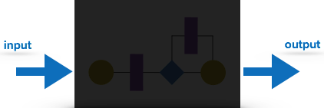

**fig 6.1 2 Black-box testing**

In this testing method, the design and structure of the code are not known to the tester, and testing engineers and end users conduct this test on the software.

Black-box testing techniques:

* **Equivalence class** - The input is divided into similar classes. If one element of a class passes the test, it is assumed that all the class is passed.
* **Boundary values** - The input is divided into higher and lower end values. If these values pass the test, it is assumed that all values in between may pass too.
* **Cause-effect graphing** - In both previous methods, only one input value at a time is tested. Cause (input) – Effect (output) is a testing technique where combinations of input values are tested in a systematic way.
* **Pair-wise Testing** - The behavior of software depends on multiple parameters. In pairwise testing, the multiple parameters are tested pairwise for their different values.
* **State-based testing** - The system changes state on provision of input. These systems are tested based on their states and input.

### **6.6 White-box testing**

It is conducted to test program and its implementation, in order to improve code efficiency or structure. It is also known as ‘Structural’ testing.

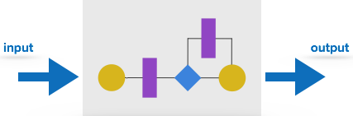

**fig 6.1 3 White-box testing**

In this testing method, the design and structure of the code are known to the tester. Programmers of the code conduct this test on the code.

The below are some White box testing techniques:

* **Control-flow testing** - The purpose of the control-flow testing to set up test cases which covers all statements and branch conditions. The branch conditions are tested for both being true and false, so that all statements can be covered.
* **Data-flow testing** - This testing technique emphasis to cover all the data variables included in the program. It tests where the variables were declared and defined and where they were used or changed.

## 6.7 Testing Levels

Testing itself may be defined at various levels of SDLC. The testing process runs parallel to software development. Before jumping on the next stage, a stage is tested, validated, and verified.

Testing separately is done just to make sure that there are no hidden bugs or issues left in the software. Software is tested on various levels -

### **6.8 Unit Testing**

While coding, the programmer performs some tests on that unit of program to know if it is error free. Testing is performed under white box testing approach. Unit testing helps developers decide that individual units of the program are working as per requirement and are error free.

### **6.8 Integration Testing**

Even if the units of software are working fine individually, there is a need to find out if the units if integrated together would also work without errors.

### **6.9 System Testing**

The software is compiled as product and then it is tested as a whole. This can be accomplished using one or more of the following tests:

* **Functionality testing** - Tests all functionalities of the software against the requirement.
* **Performance testing** - This test proves how efficient the software is. It tests the effectiveness and average time taken by the software to do desired task. Performance testing is done by means of load testing and stress testing where the software is put under high user and data load under various environment conditions.
* **Security & Portability** - These tests are done when the software is meant to work on various platforms and accessed by number of persons.

### Acceptance Testing

* When the software is ready to hand over to the customer it has to go through last phase of testing where it is tested for user-interaction and response. This is important because even if the software matches all user requirements and if user does not like the way it appears or works, it may be rejected.
* **Alpha testing** - The team of developer themselves perform alpha testing by using the system as if it is being used in work environment. They try to find out how user would react to some action in software and how the system should respond to inputs.
* **Beta testing** - After the software is tested internally, it is handed over to the users to use it under their production environment only for testing purpose. This is not as yet the delivered product. Developers expect that users at this stage will bring minute problems, which were skipped to attend.

### **6.11 Regression Testing**

Whenever a software product is updated with new code, feature or functionality, it is tested thoroughly to detect if there is any negative impact of the added code. This is known as regression testing.

## Testing Documentation

Testing documents are prepared at different stages -

### Before Testing

Testing starts with test cases generation. Following documents are needed for reference –

* **SRS document** - Functional Requirements document
* **Test Policy document** - This describes how far testing should take place before releasing the product.
* **Test Strategy document** - These mentions detail aspects of test team, responsibility matrix and rights/responsibility of test manager and test engineer.
* **Traceability Matrix document** - This is SDLC document, which is related to requirement gathering process. As new requirements come, they are added to this matrix. These matrices help testers know the source of requirement. They can be traced forward and backward.

### While Being Tested

The following documents may be required while testing is started and is being done:

* **Test Case document** - This document contains list of tests required to be conducted. It includes Unit test plan, Integration test plan, System test plan and Acceptance test plan.
* **Test description** - This document is a detailed description of all test cases and procedures to execute them.
* **Test case report** - This document contains test case report because of the test.
* **Test logs** - This document contains test logs for every test case report.

### After Testing

* he is following documents may be generated after testing:
* **Test summary** - This test summary is collective analysis of all test reports and logs. It summarizes and concludes if the software is ready to be launched. The software is released under version control system if it is ready to launch.

## 6.12 Testing vs. Quality Control, Quality Assurance and Audit

* We need to understand that software testing is different from software quality assurance, software quality control and software auditing.
* **Software quality assurance** - These are software development process monitoring means, by which it is assured that all the measures are taken as per the standards of organization. This monitoring is done to make sure that proper software development methods were followed.
* **Software quality control** - This is a system to maintain the quality of software product. It may include functional and non-functional aspects of software product, which enhance the goodwill of the organization. This system makes sure that the customer is receiving quality product for their requirement and the product certified as ‘fit for use’.
* **Software audit** - This is a review of procedure used by the organization to develop the software. A team of auditors, independent of development team examines the software process, procedure, requirements, and other aspects of SDLC. The purpose of software audit is to check that software and its development process both confirm standards, rules, and regulations.

**CHAPTER 7**

# **SALESFORCE**

Salesforce is a cloud-based technology and one of the largest global web-based Software and Cloud Computing Company which is known as ***“Customer Relationship Management (CRM)”*** product founded in 1999 by former Oracle executive Marc Benioff, Parker Harris, Dave Hoelterhoff, and Frank Dominguez.

Salesforce with their first release offered CRM product and later they released API (Application Programming Interface) for exposing data on their server to clients via protocols. After many updates, Salesforce released a proprietary language called Apex (syntactically like Java).

Salesforce is not just a Customer Relationship Management tool, it provides Software, Platform, and Infrastructure as a Service. We can call Salesforce.com as a Salesforce automation (SFA) tools, where the user can develop several applications, Website and portals using drag and drop environment.

* Salesforce is one type of database which has different and fancy User Interface.
* Salesforce.com User Interface is built with many support functions like accounts, contacts, Sales opportunities, Chatters, Quotes and many more.
* Salesforce.com cloud application platform is sold as a subscription.

 Salesforce.com offers its services through four different clouds:

1. Sales Cloud.
2. Service Cloud.
3. Collaboration Cloud.
4. Force.com Custom Cloud.

7.1 **Salesforce ORG:**

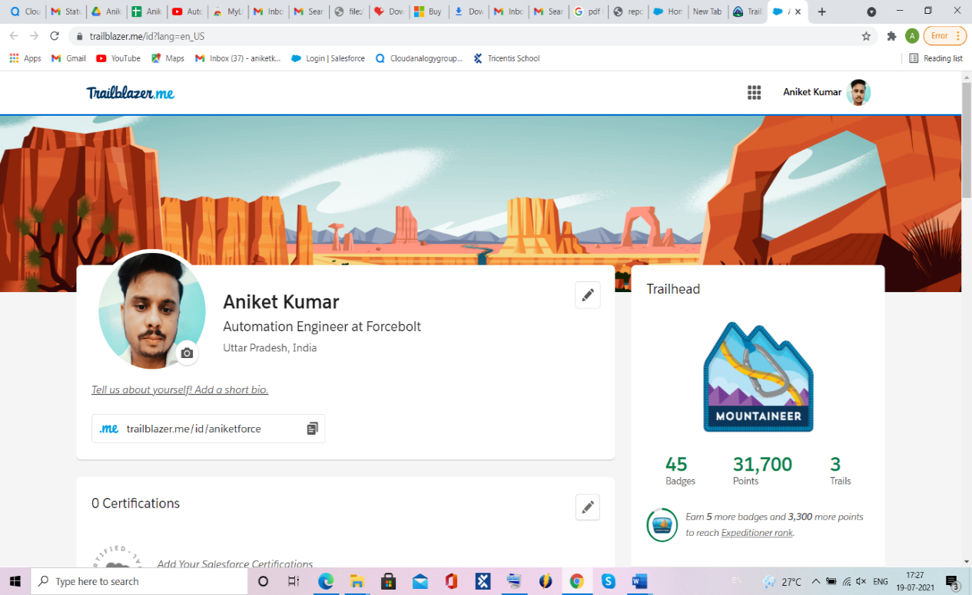

**fig 7.1 5 Salesforce ORG:**

Salesforce org where we can complete the trailhead and learned new skills

**7.2 Why Salesforce?**

Salesforce is unique and provides the fastest path from Idea to App. In other legacy platforms, to build an application we require hardware, software, permissions access and many more.

* Salesforce is a number one on-demand CRM.
* It requires no infrastructure.
* World’s most trusted cloud.
* We can build anything with our own apps and with Salesforce App Exchange free applications.
* Powerful and pre-built application available at AppExchange

**7.3 Salesforce Lighting ORG**

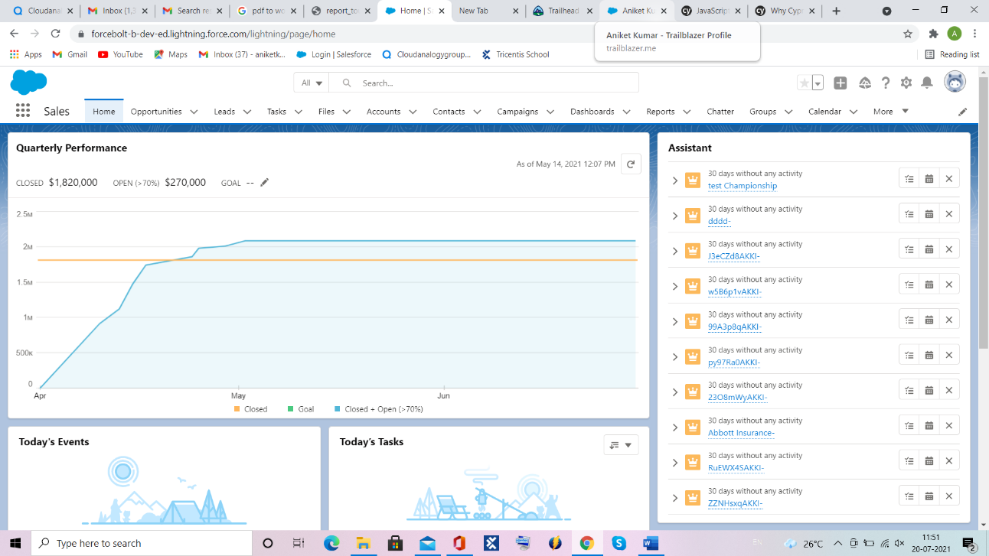

**fig 7.1 6 Salesforce Lighting ORG**

**7.4 Salesforce Classic ORG**

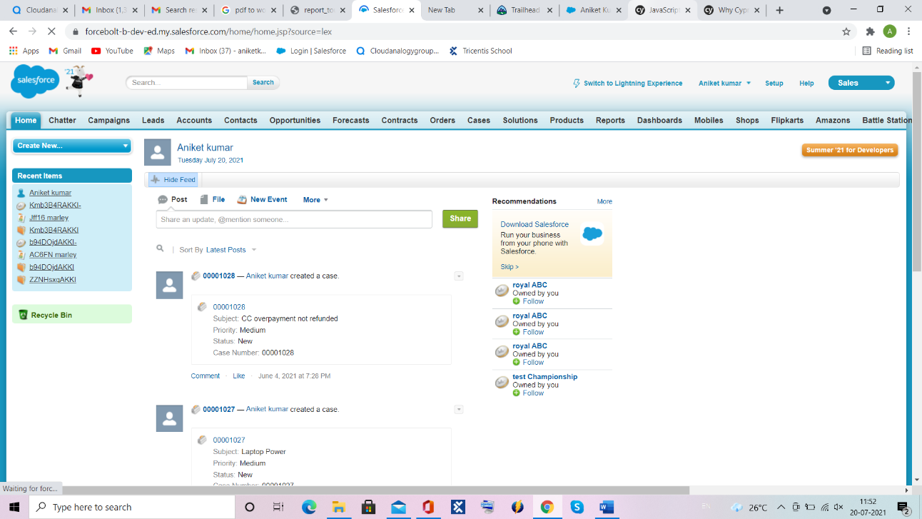

**fig 7.1 7 Salesforce Classic ORG**

**7.5 Sandbox ORG**

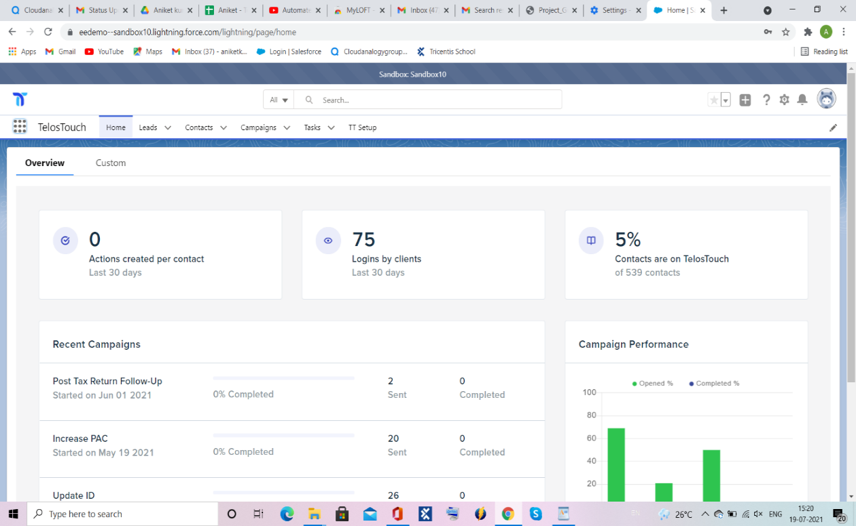

**fig 7.1 8 Sandbox ORG (home)**

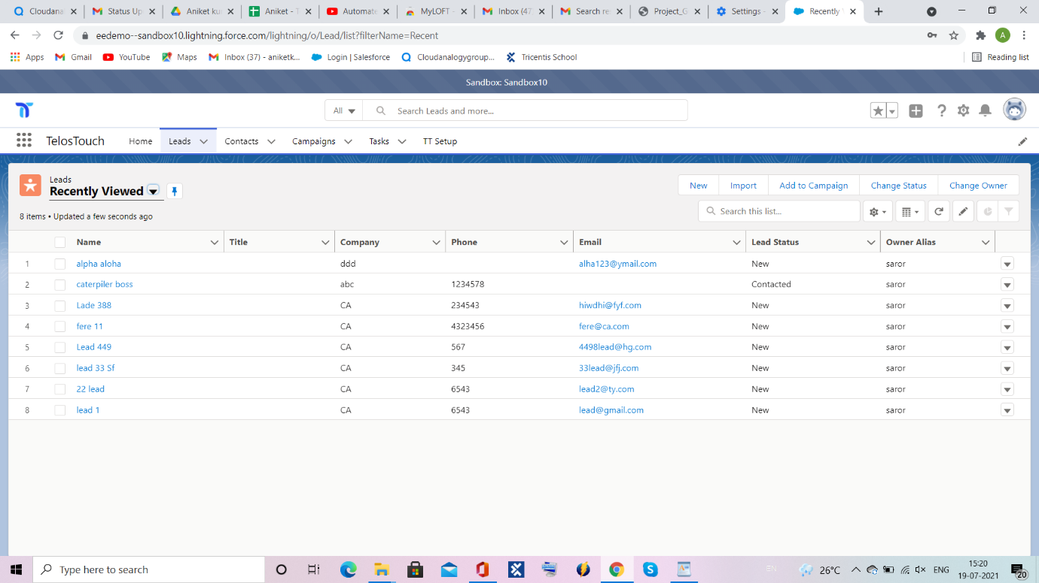

**fig 7.1 9 Sandbox ORG (Leads)**

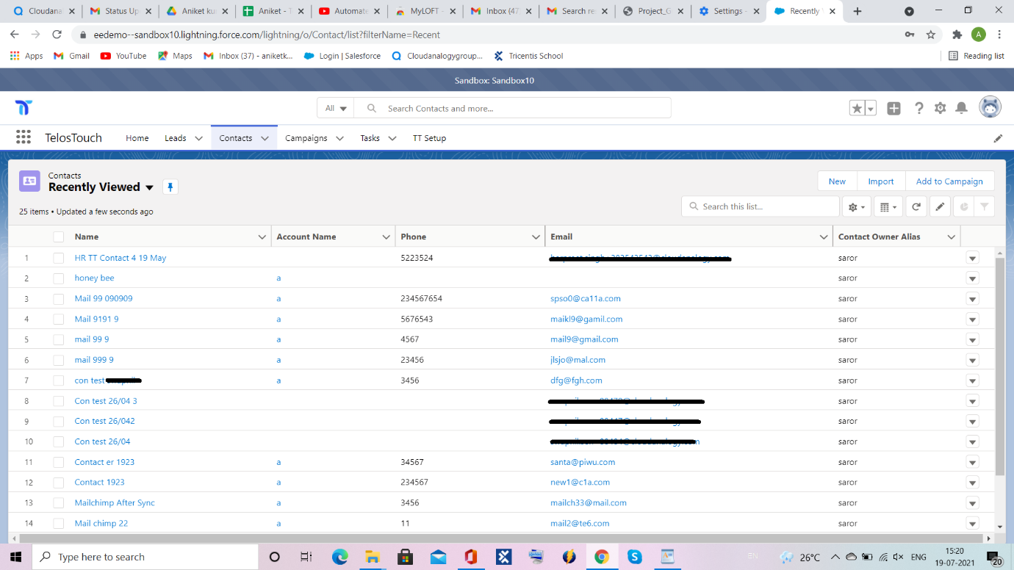

**fig 7.1 10 Sandbox ORG (Contacts)**

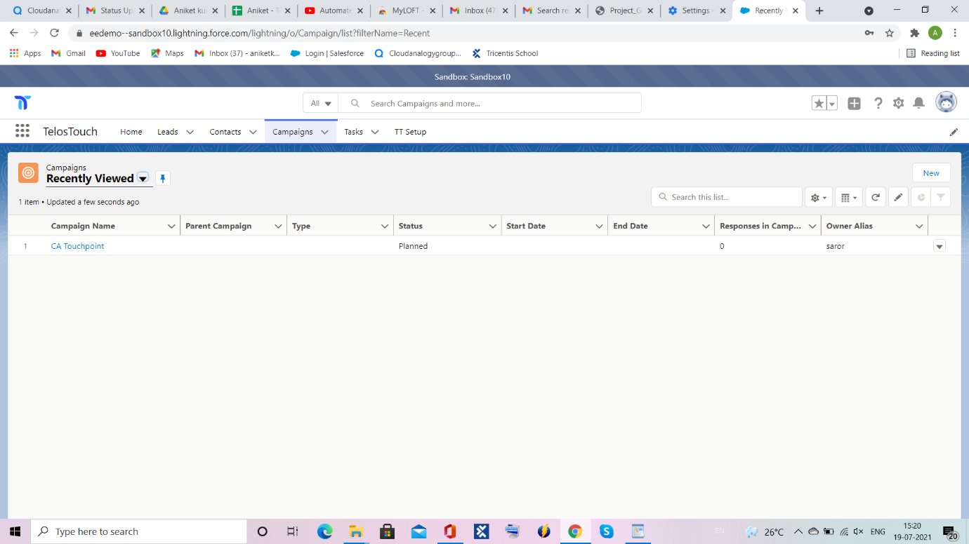

**fig 7.1 11 Sandbox ORG (Campaign’s)**

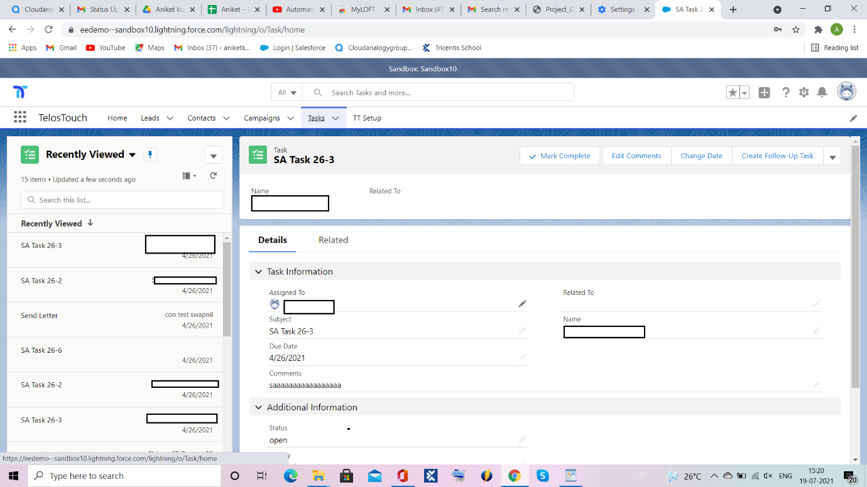

**fig 7.1 12 Sandbox ORG (Tasks)**

This is the ORG where I test the component according to test cases scenario.

In this Sandbox org, there the many objects like Case, Contact, Business Function, Case Categories, Workspace etc. we must test all the object as per requirement when any new changes in org happen then we must perform unit testing as per tickets also we perform regression testing on every component to very that no issue is created in ORG because of any new changes.

**7.6** **Apex jobs**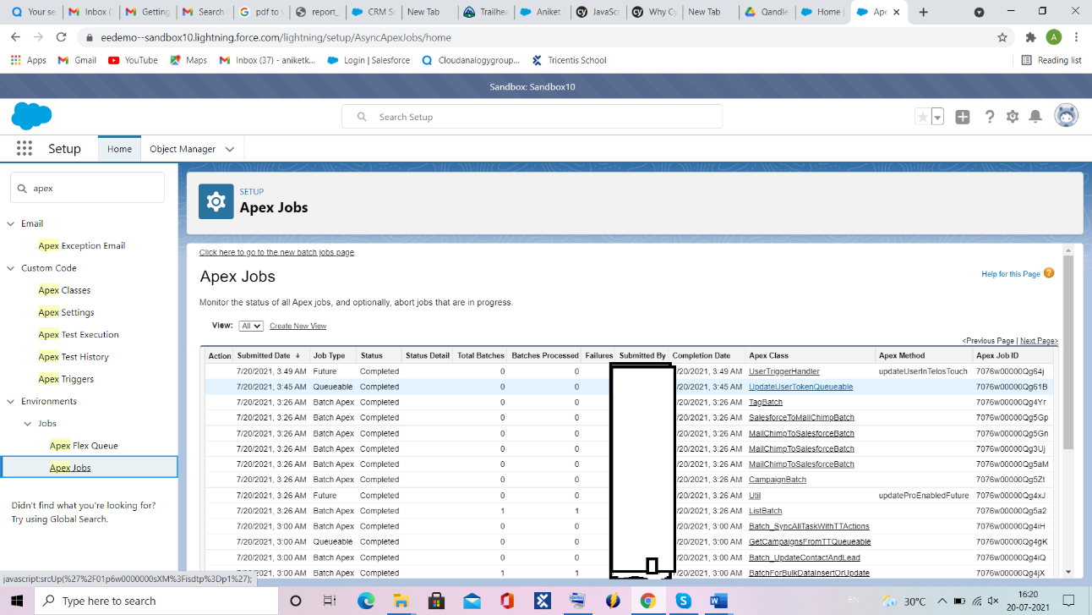

**fig 7.1 13 Apex jobs**

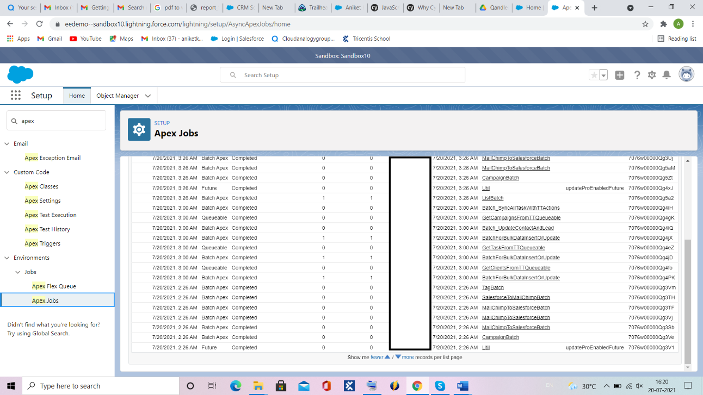

**fig 7.1 14 Apex jobs**

**7.7 Apex classes**

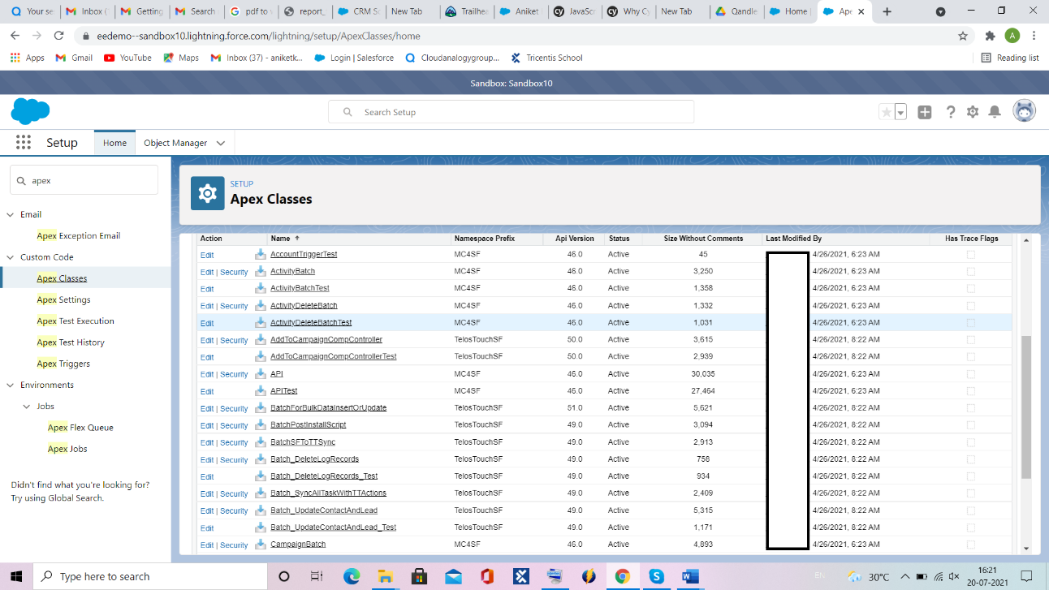

**fig 7.1 15 Apex classes**

**7.8** **Apex Trigger**

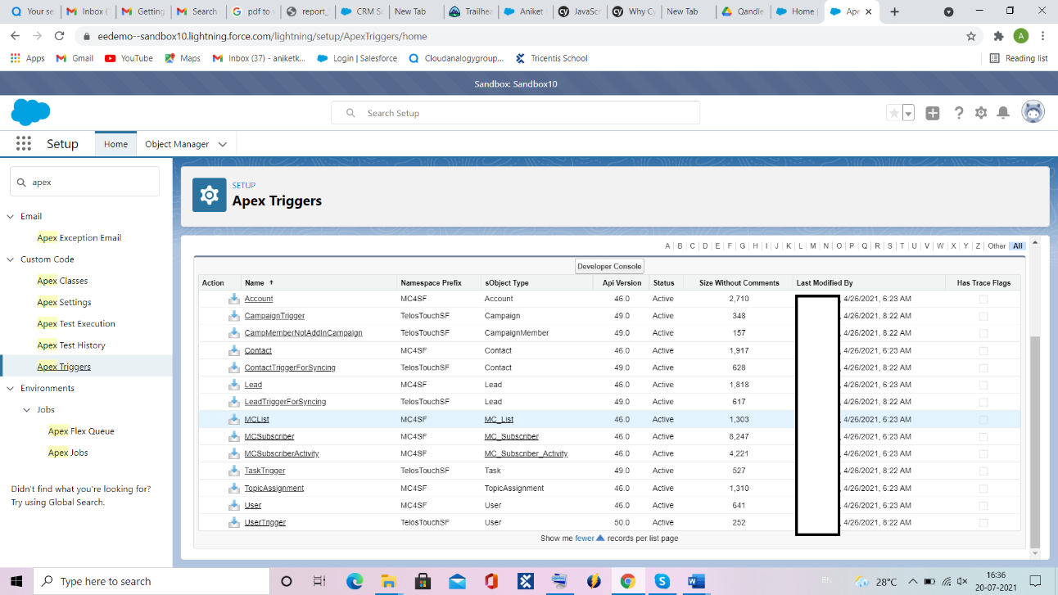

**fig 7.1 16 Apex Trigger**

**CHAPTER 8**

**Output Screen**

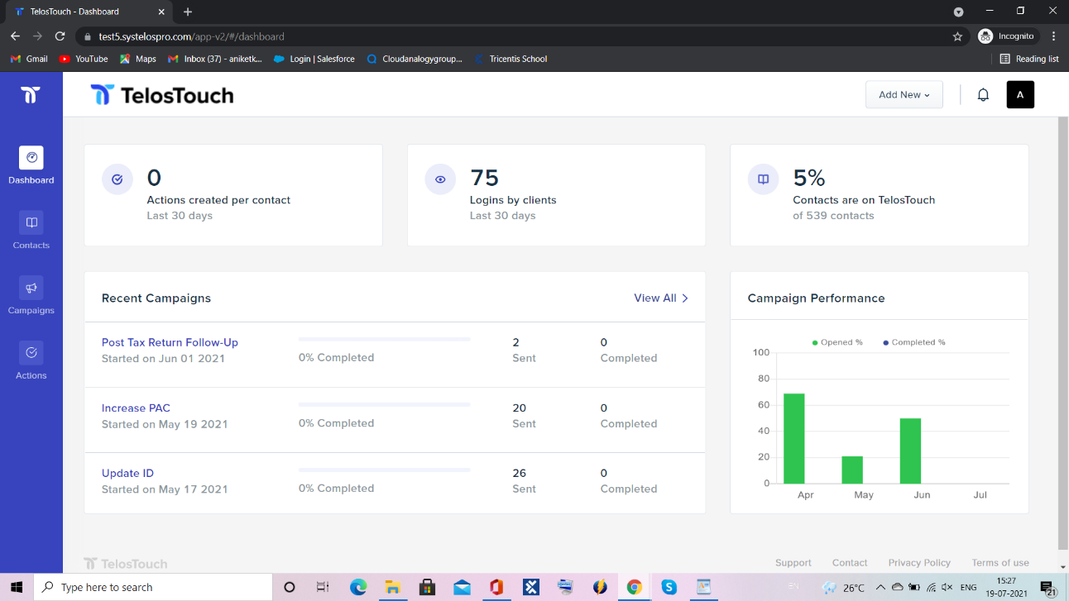

**fig 8.1 11 Dashboard**

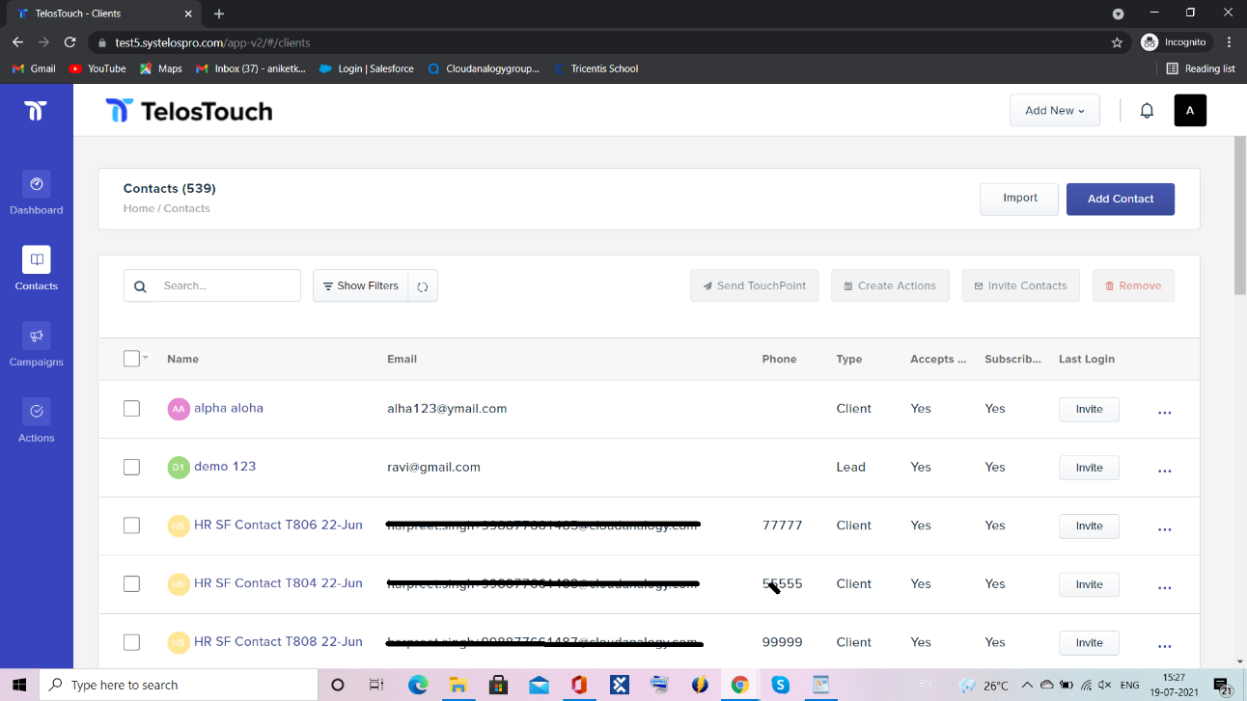

**fig 8.1 12 Contacts**

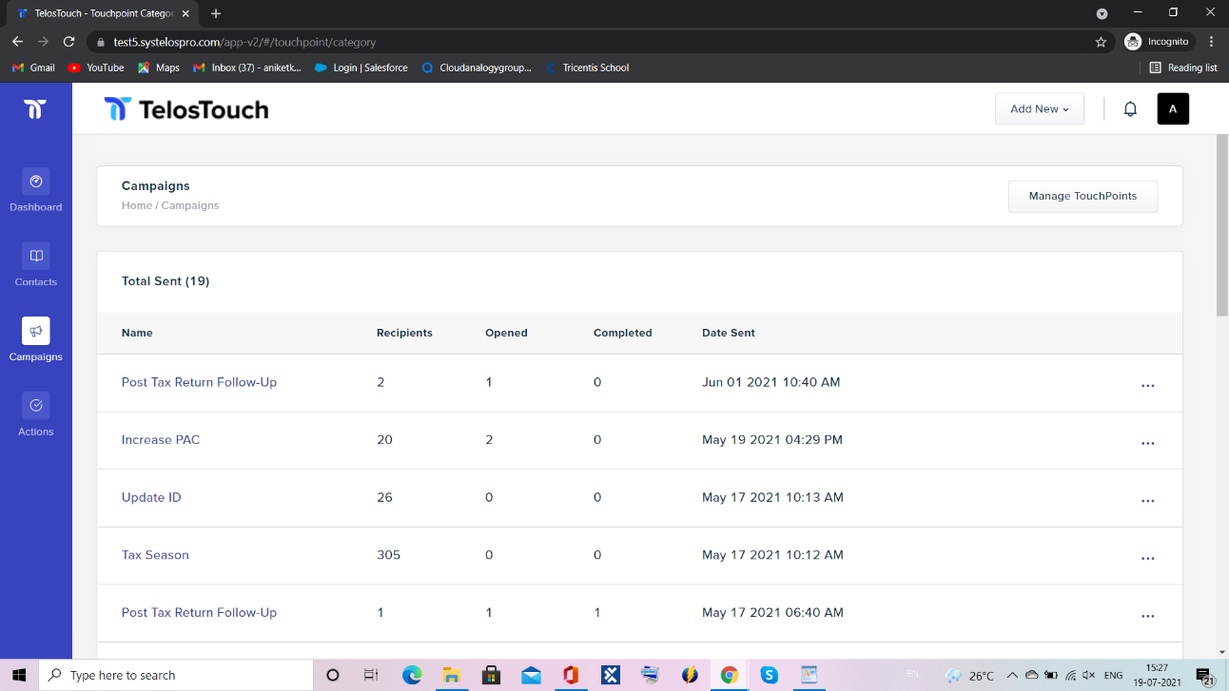

**fig 8.1 13 Campaign’s**

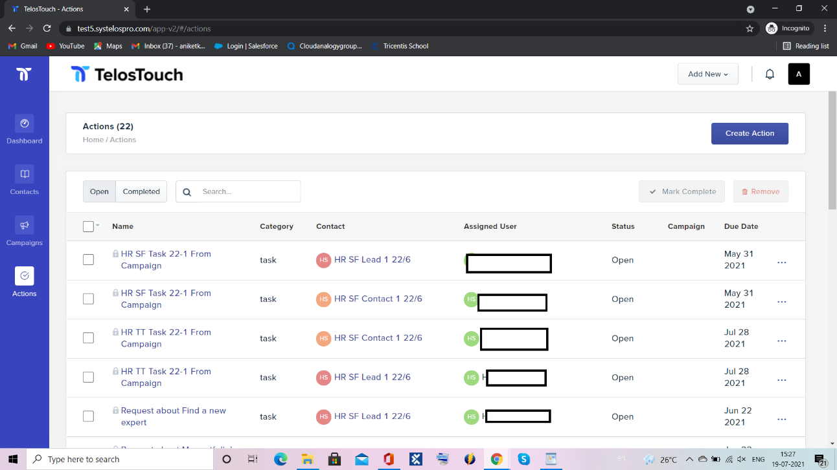

**fig 8.1 14 Actions**

**CHAPTER 9**

**Introduction to Assigned Job**

As a Tester my main work is to test every possible functionality of each component of the module. I must create test cases for the assigned testing task. In this I must choose the best scenario to explain the component

and then write description for the component and test the functionality that the component is working fine or not. When component is working fine than I saved it as pass and moved to the next scenario of the component but when the component is failed, I have to create evidence for the same and create bug which I assigned to the development team to correct the failure scenario and then again doing the retesting for the component that all the things is working fine as per acceptance criteria.

Key Points:

* Work closely with project managers and developers and handle multiple work
* Execute manual and automated test cases, analyze results, report and track defects, verify fixes and perform follow-up work to resolve issues
* Lead teams to create and execute test plans and scripts that will determine optimal application performance according to specifications
* Work closely with project managers and developers and handle multiple priorities simultaneously
* Assists and cooperates with co-workers, supervisor and management
* Work with automation team to develop and execute automated tests
* Responsible for all aspects of the QA cycle for assigned projects
* Developing Test Cases, Test Strategies and Test Plans that will ensure comprehensive test coverage
* Conducting hands on functional, and system integration testing; report, track and follow up on issues in a timely manner
* Working closely with technical and non‐technical peers and senior management to promote successful delivery of products and services
* Supporting continuous improvement of the current test process
* Knowledge in writing basic SQL queries and end to end workflow
* Solid expertise in testing Buy/Sell Side Order Management Systems
* Assist with developing test plan timeline

Conversational agent or Chatbot is a program that generates response based on given in-

put to emulate human conversations in text or voice mode. These applications are de-

signed to simulate human-human interactions. Chatbots are predominantly used in business and corporate organizations including government, nonprofit and private ones. Their

functioning can range from customer service, product suggestion, product inquiry to personal assistant. Many of these chat agents are built using rule-based techniques, retrieval

techniques or simple machine learning algorithms. In retrieval-based techniques, chat

agents scan for keywords within the input phrase and retrieves relevant answers based on

the query strings. They rely on keyword similarity and retrieve text is pulled from internal

or external data sources including world wide web or organizational database. Some other

advanced chatbots are developed with natural language processing (NLP) techniques and

machine learning algorithms. Also, there are many commercial chat engines available,

which help build chatbots based on client data input signed to simulate human-human interactions. Chatbots are predominantly used in business and corporate organizations including government, nonprofit and private ones. Their functioning can range from customer service, product suggestion, product inquiry to personal assistant.

Many of these chat agents are built using rule-based techniques, retrieval techniques or simple machine learning algorithms.

In retrieval-based techniques, chat agents scan for keywords within the input phrase and retrieves relevant answers based on the query string. They rely on keyword similarity and retrieve text is pulled from internal or external data sources

including world wide web or organizational database. Some other advanced chatbots are developed with natural language processing (NLP) techniques and machine learning algorithms. Also, there are many commercial chat engines available, which help build chatbots based on client data input.

## 3 Ways to Test:

There are 3 ways you can do testing.

**Manual testing** is the most hands-on type of testing and is employed by every team at some point. Of course, in today’s fast-paced software development lifecycle, manual testing is tough to scale.

**Automated testing**uses test scripts and specialized tools to automate the process of software testing.

**Continuous testing** goes even further, applying the principles of automated testing in a scaled, continuous manner to achieve the most reliable test coverage for an enterprise. Keep reading to learn more about the differences between [automated testing vs. manual testing](https://www.perfecto.io/blog/automated-testing-vs-manual-testing-vs-continuous-testing) and how continuous testing fits in.

## Types of Automation Testing

There are several tests automation types — and frameworks and tools to support them

Considering automating tests? Find out:

* Why test automation is important.
* Which tests you should automate.
* How automated testing should work.

In Automation Testing My job is to creating Buckets in Q-Test and Run through Automation.

And write test cases for the related tickets and verify it Manually.

**CHAPTER 10**

**Installation and Configuration Guide(TelosTouch App)**

**STEP 1:**

**For installing the Telos touch App in SF Production Org click the below link**

[**https://login.salesforce.com/packaging/installPackage.apexp?p0=04t2w000009MgR8**](https://login.salesforce.com/packaging/installPackage.apexp?p0=04t2w000009MgR8)

**STEP 2: Enter the username and password of the Installation Org in which you want to install the TT package.**

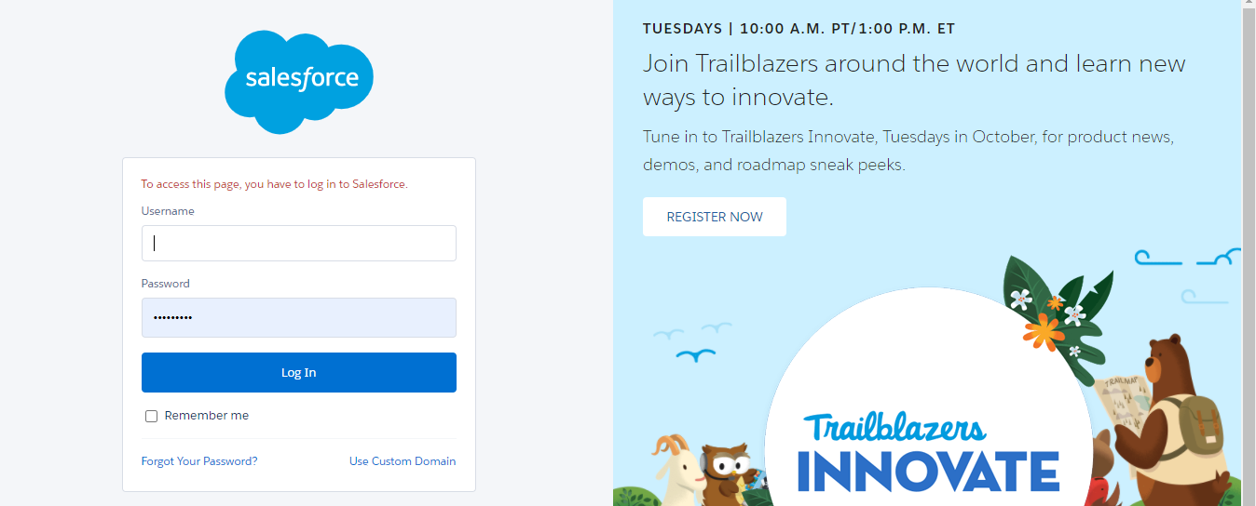

**fig 10.1 1 Salesforce login page**

**STEP 3: Select the Install for All Users option and select the checkbox. Then click the Install button.**

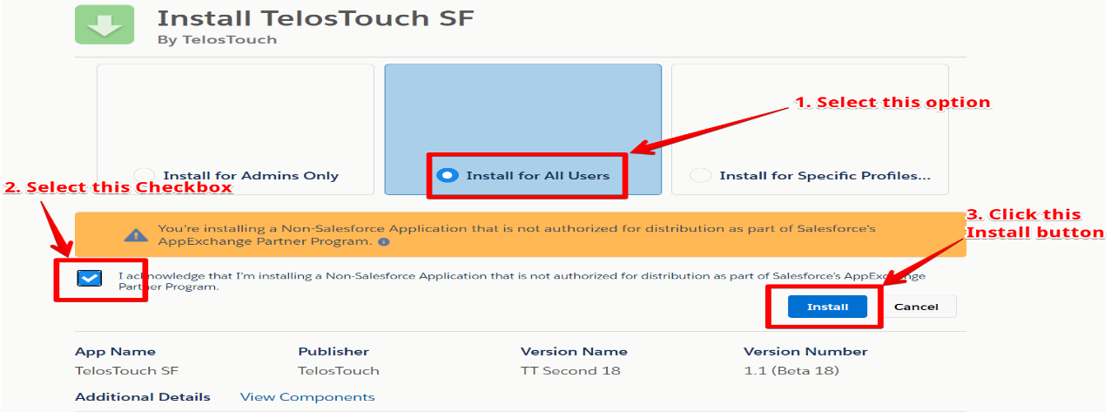

**fig 10.1 2 Installation**

**STEP 4: Click the Done button.**

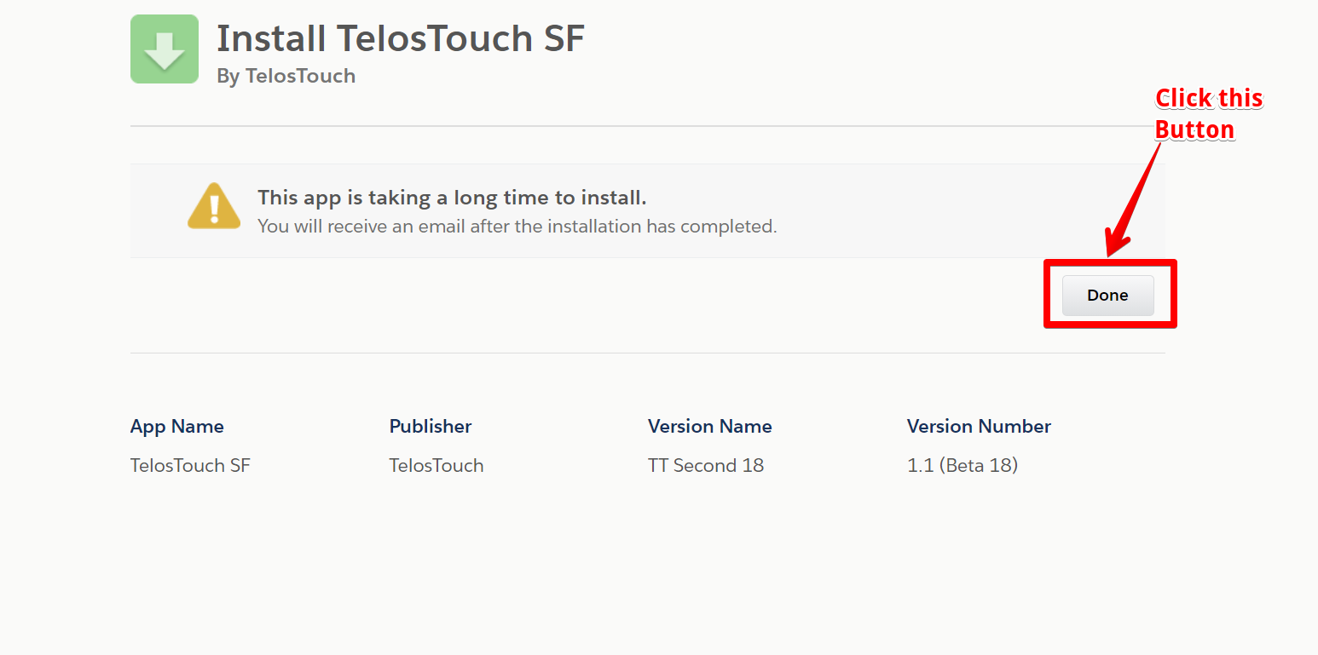

**fig 10.1 3**

**STEP 5: Click the App Launcher icon. Then type Telos Touch and then select the Telos Touch App Icon.**

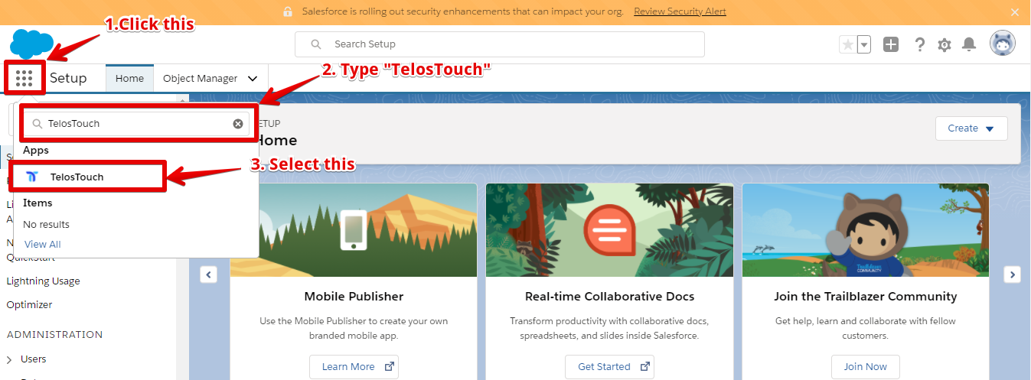

**fig 10.1 4**

**STEP 6: Click the “TT Setup” Tab and then click the Edit button below:**

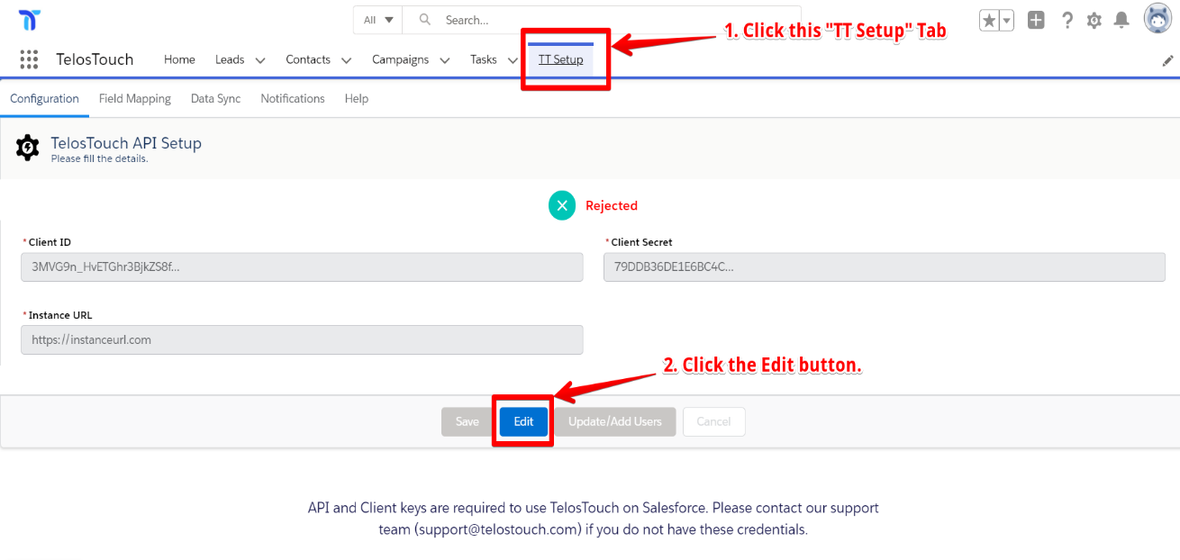

**fig 10.1 5**

**STEP 7: To configure the App, Fill in the Client ID, Client Secret, and Instance URL Fields. After filling in, these details click the Save button.**

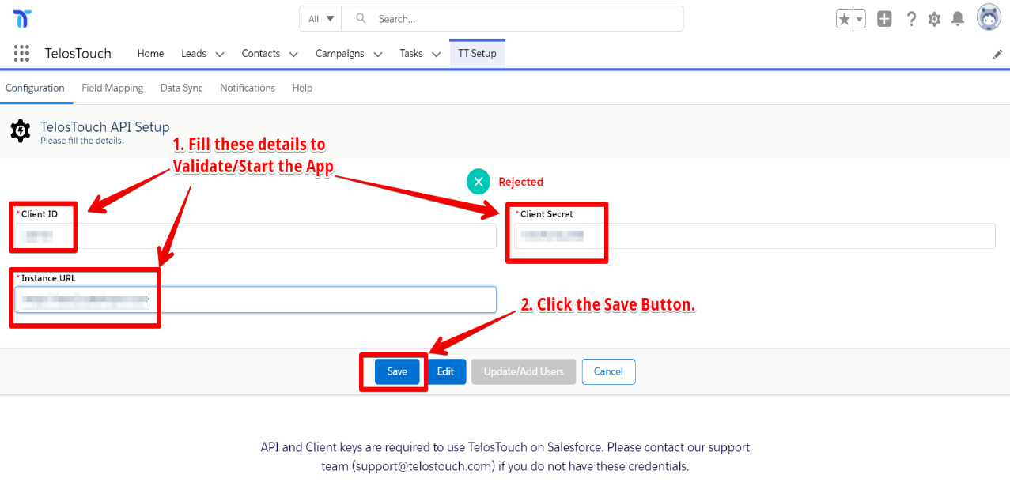

**fig 10.1 6**

**STEP 8: Select the Advisor Users from the list of users for which you want to configure the Telos Touch app. Then click the “Send to Telos Touch” Button. Also, make sure that the SF Users using the Telos Touch App should have the “Marketing user checkbox” as TRUE.**

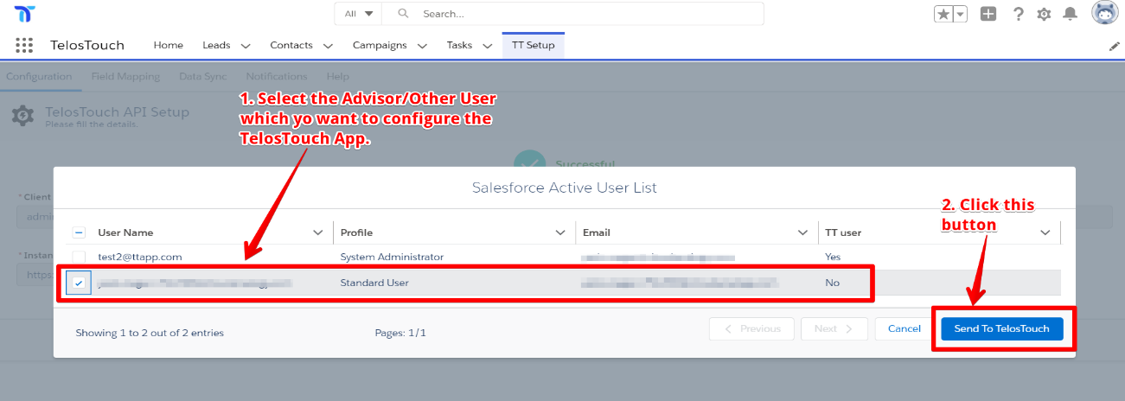

**fig 10.1 7**

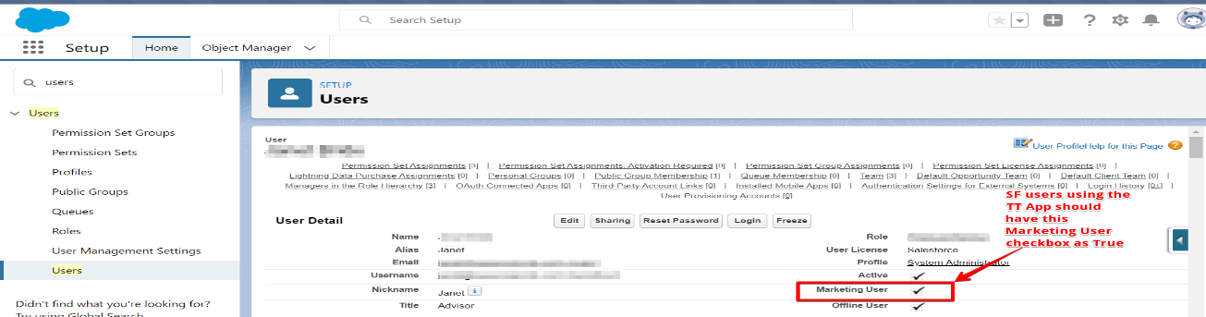

**fig 10.1 8**

**STEP 9: Follow the given process to add the list view button on objects like Contact, Lead, Client (person Account) with name “Add to Campaign” “Create =Task”, “Invite”:**

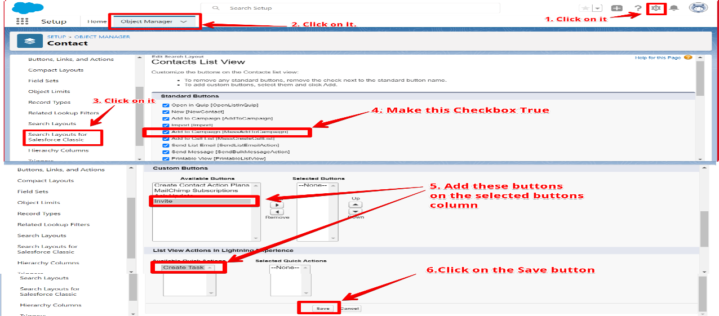

**fig 10.1 9**

**Step 10- For showing the “Create Task” button on the list views of Contact, Lead and Person Account we need to select the master Record type in the user profile.**

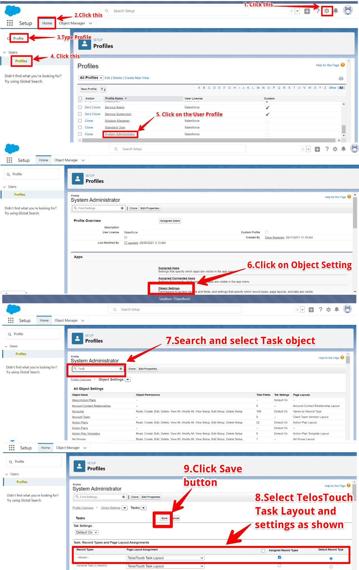

**fig 10.1 10**

**Step 11 - Add TT fields in default Task object layout which is assigned to the user profile.**

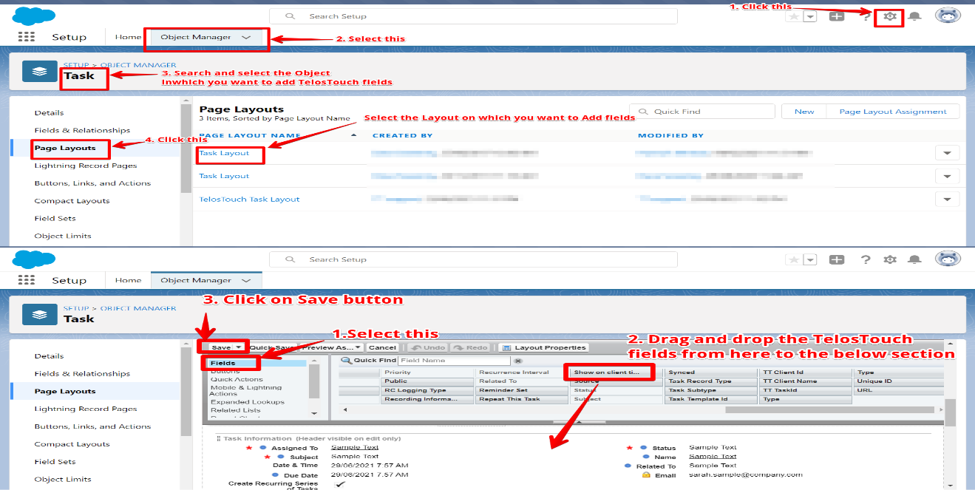

**fig 10.1 11**

**Step 12- For adding “New Task” button on Lead, Contact and Person Account view page we need to do following configuration**

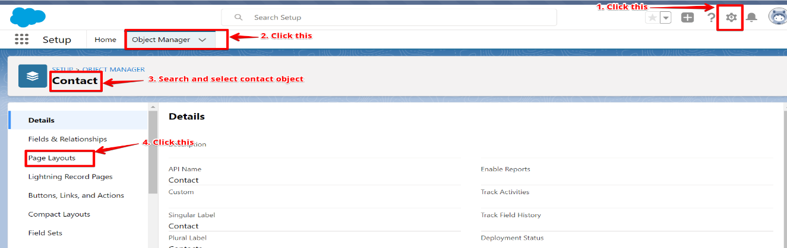

**fig 10.1 12**

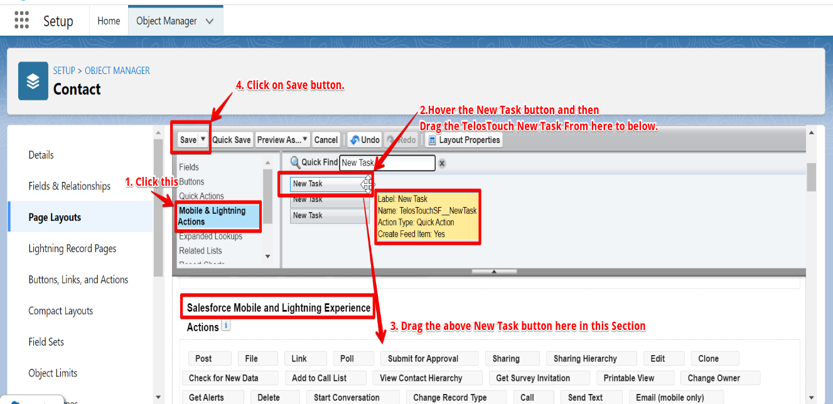

**fig 10.1 13**

**Step 13 - For adding “New Task” button in Global action we need to add TT New Task button in the publisher layout. After this you can see the TT layout.**

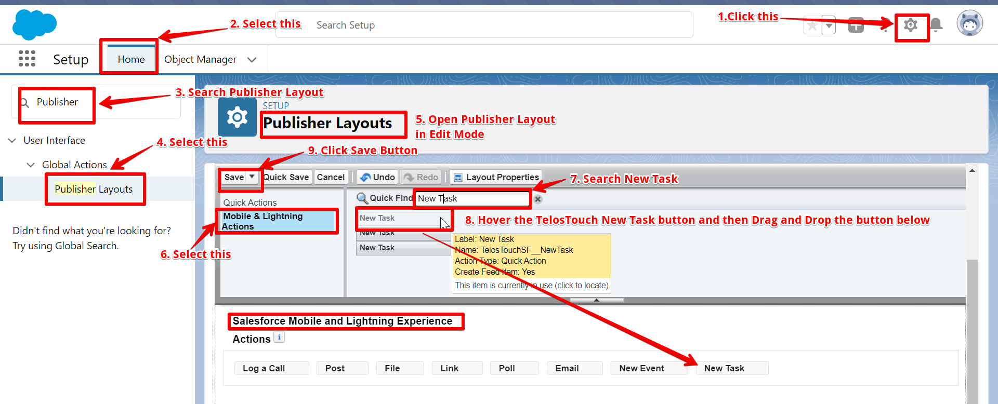

**fig 10.1 14**

**STEP 14: For adding the “TT Client Answers” in the related list of Contact, Lead, Client (person Account) objects, do the following:**

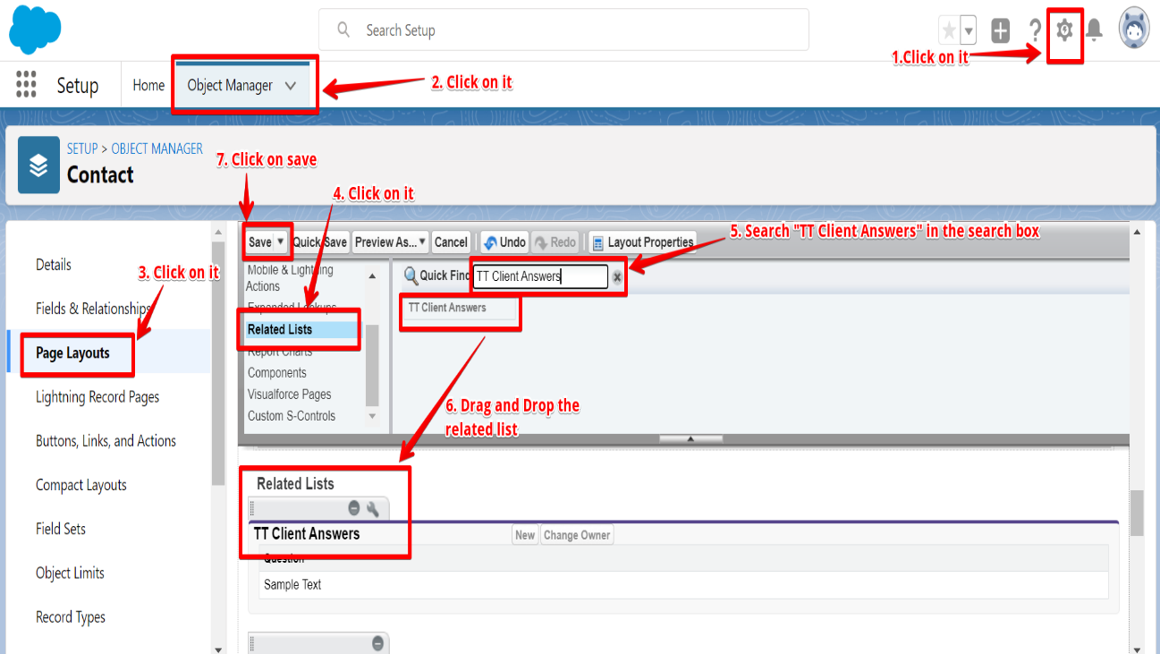

**fig 10.1 15**

**STEP 15: In the Lead, Contact, and Task object assigns the Telos Touch Page-Layouts from the Page layout assignment section of the object to the System Administrator and Standard user profile. Page Layout assignment is like be done on Contact and Task object, as shown below for the Lead Object.**

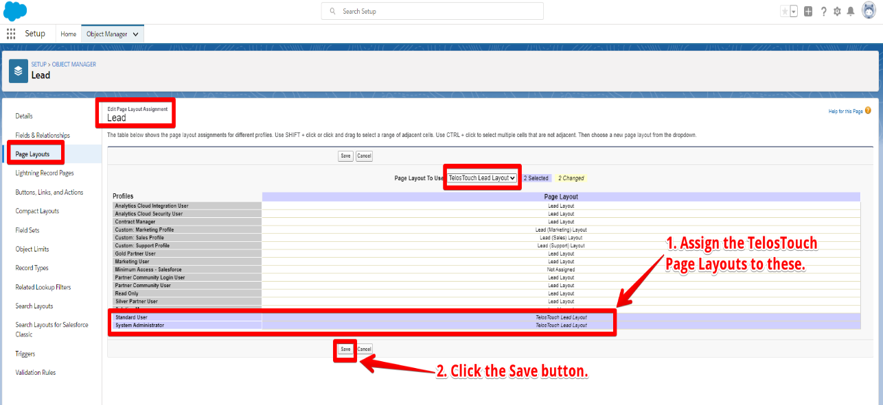

**fig 10.1 16**

**STEP 16: For Client (Person Account) create List view with name “TT Clients” in the following way:**

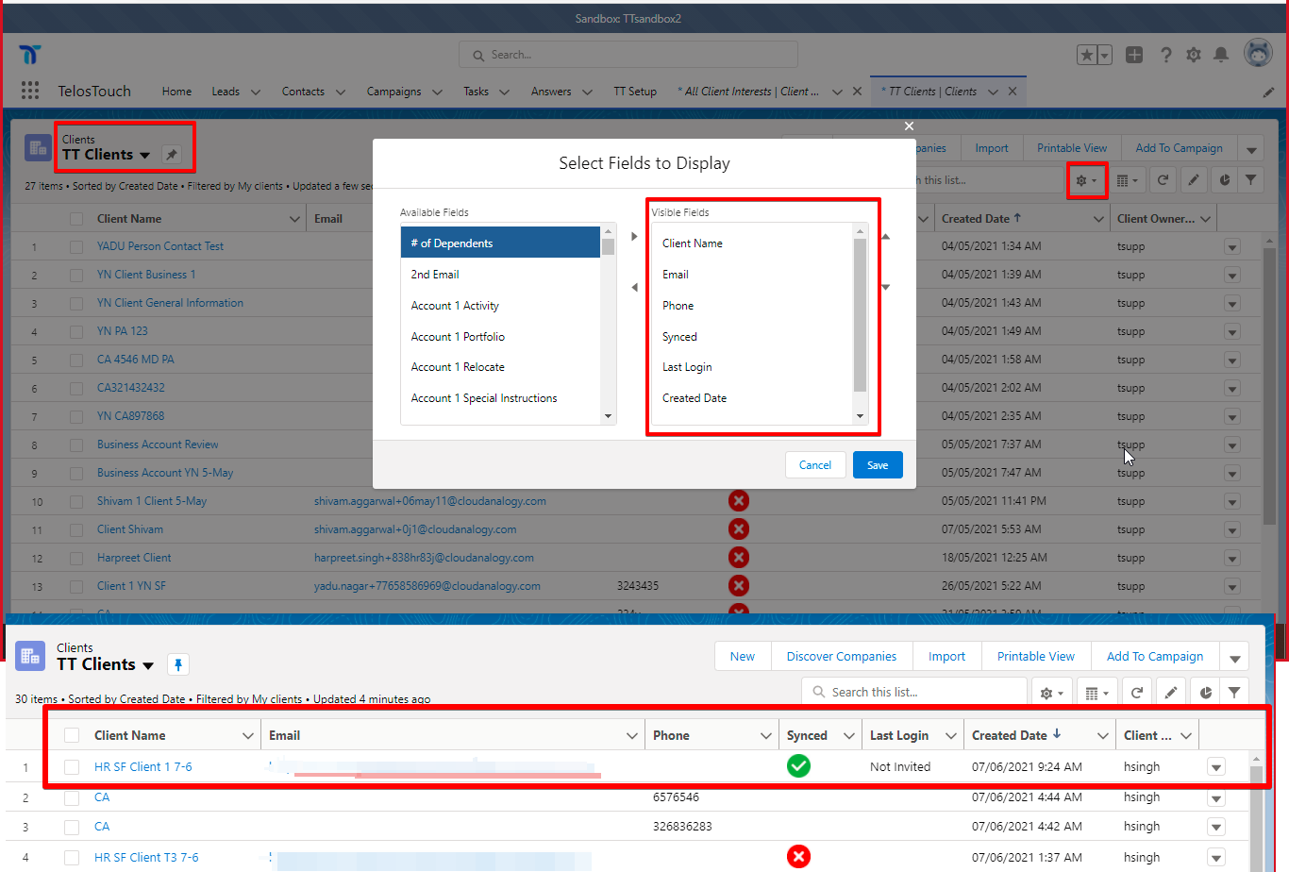

**fig 10.1 17**

**STEP 17: If the activity timeline is not showing on the Lead and Contact record page then follow these steps shown in the image below.**

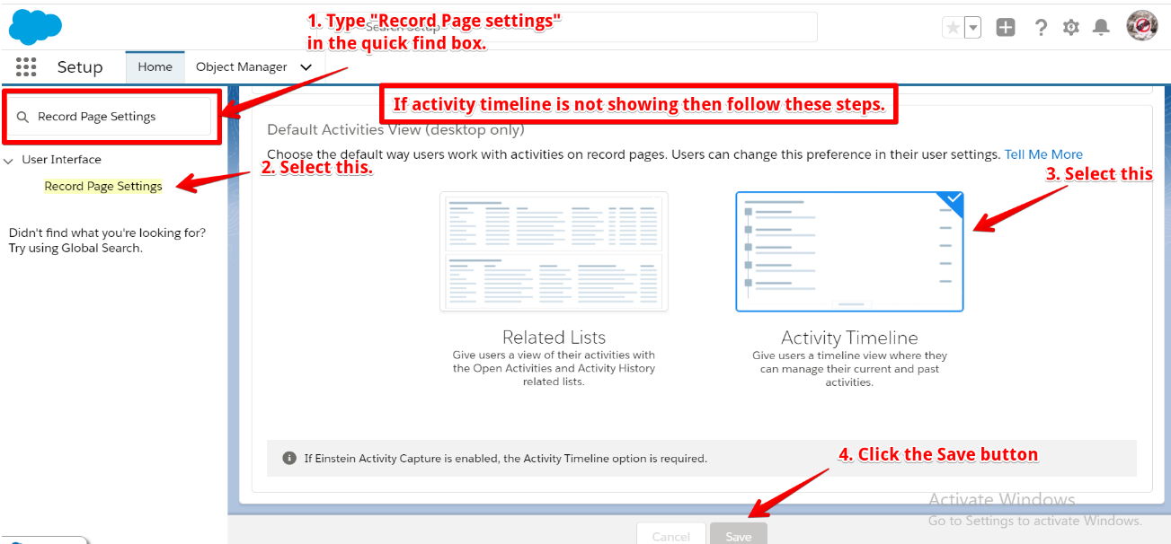

**fig 10.1 18**

**CHAPTER 11**

**CONCLUSION**

A software project means a lot of experience. We learned a lot through this project. This project has sharpened My concept, learned new techniques and the software-hardware interface. We learned a lot about different documentation. Now I have much wider knowledge of the features **Salesforce** and put into practice various Salesforce methods that learnt last semester.

Through this project I learned how to perform manual testing how we test the application, how to work on Salesforce administration and Learned How to Create, Objects, Leads, Account Cases And many more with help of our project Mentors.

**CHAPTER 12**

**REFERENCES**

**Journal Research Papers**:

[1] Adam Roman (Thinking-Driven testing: A Universal Testing Framework)

1st Edition

Publisher: Springer, Cham

Pages; 99-143

<https://link.springer.com/chapter/10.1007/978-3-319-73195-7_3>

[2] Milad Hanna Software Testing: A Research Travelogue (2000–2014)

<https://www.engpaper.com/free-research-papers-computer-science-software->

[3] Lin Ma (Software Bug Localization Based on Key Range Invariants)

Research paper from: School of Information Science and Technology, Zhejiang Sci-Tech University, Hangzhou 310019, Zhejiang, China

<https://link.springer.com/content/pdf/10.1007%2F978-3-030-04272-1_2.pdf>

[4] Mukesh Sharma (Leveraging the Wisdom of the Crowd in Software Testing)

1st Edition

Publisher: Auerbach Publications

<https://www.taylorfrancis.com/books/9780429189722>

[5] Oliver Measly (Project Feasibility)

1st Edition

Publisher: Boca Raton  
<https://www.taylorfrancis.com/books/9781315295251>

[6] Rajesh K Maurya (Software testing, ISBN 9789350044001,

Publisher: Wiley

<https://ebooks.wileyindia.com/pdfreader/software-testing>)

[7] Rajini Padmanabhan (Leveraging the Wisdom of the Crowd in Software Testing)

1st Edition

Publisher: Auerbach Publications

<https://www.taylorfrancis.com/books/9780429189722>

[8] Swati R Maurya (Software testing, ISBN 9789350044001,

Publisher: Wiley

<https://ebooks.wileyindia.com/pdfreader/software-testing>)

[9] Zohra Ding (Software Bug Localization Based on Key Range Invariants)

Research paper from: School of Information Science and Technology, Zhejiang Sci-Tech University, Hangzhou 310019, Zhejiang, China

<https://link.springer.com/content/pdf/10.1007%2F978-3-030-04272-1_2.pdf>